**User manual and Testing plan**

**Game Shelf**

Board Game Renting Platform

Presented to

Asst.Prof.Dr. Pittipol Kantavat

by

Pavee Jeungtanasirikul 6530249621

Panupong Nantasung 6530310121

Warintorn Surapolchai 6530360521

Winithra manolertthwan 6530375021

Aunyapat Nitijarasrat 6530428621

Bhanarin Hanthomrongwit 6531334421

Warissara Booranamaitree 6532152721

2110336 Software Engineering II

2nd Semester, 2024

Department of Computer Engineering Faculty of Engineering,

Chulalongkorn University

**Table of Content**

Testing plan 2

Function: Register 2

Input Equivalence Classes 2

Test Cases 2

Function: Player Login 4

Input Equivalence Classes 4

Test Cases 4

Function: Search board game 6

Input Equivalence Classes 6

Test Cases 6

Function: Player send rental request 9

Input Equivalence Classes 9

Test Cases 10

Test Coverage Matrix 13

User Manual 14

Function : Search board game / provider 14

Function : Register / Login 16

Function : Profile Settings 18

Function : Send rental request 19

Function : Pay the rental 21

Function : Check rental status 22

Function : Add picture when Receive / Return board games 23

Function : Review board games 24

Function : Report 25

Function : Notification 26

Function : Provider verification 27

Function : Add board game 29

Function : Manage rental request 31

Function : Manage shipping 32

Function : Provider dashboard 34

Function : Check Review 35

Function : Income history 36

Function : Manage provider 37

Function : Manage report 38

Function : Report statistic / Unban 40

Function : Report history 41

Limitations of the implementation 41

# Testing plan

## Function: Register

### Input Equivalence Classes

| **Equivalent Class ID** | **Input** | **Validation** |
| --- | --- | --- |
| 1 | Email exists in the system | Invalid |
| 2 | Email does not exist in the system | Valid |
| 3 | Role is not selected | Invalid |
| 4 | Role is selected as “Player” or “Provider” | Valid |
| 5 | Password is an empty string | Invalid |
| 6 | Password is correct format | Valid |

### Test Cases

Assume that

* Email “player888@gmail.com” exists in the system as “Player”
* Email “newplayer01@gmail.com ” does not exist in the system

| **Test Case ID** | TC1-1 |  |
| --- | --- | --- |
| **Inputs** | Email | “player888@gmail.com” |
|  | Password | “12345678” |
|  | Username | “testPlayer” |
|  | Role | “Player” |
| **Expected Outputs** | Invalid |  |
| **Actual Outputs** | Invalid |  |
| **Equivalence Classes Covered** | 1, 4, 6 |  |

| **Test Case ID** | TC1-2 |  |
| --- | --- | --- |
| **Inputs** | Email | “newplayer01@gmail.com” |
|  | Password | “12345678” |
|  | Username | “testPlayer” |
|  | Role | “Player” |
| **Expected Outputs** | Valid |  |
| **Actual Outputs** | Valid |  |
| **Equivalence Classes Covered** | 2, 4, 6 |  |

| **Test Case ID** | TC1-3 |  |
| --- | --- | --- |
| **Inputs** | Email | “newplayer01@gmail.com” |
|  | Password | <Empty String> |
|  | Username | “testPlayer” |
|  | Role | “Player” |
| **Expected Outputs** | Invalid |  |
| **Actual Outputs** | Invalid |  |
| **Equivalence Classes Covered** | 2, 4, 5 |  |

| **Test Case ID** | TC1-4 |  |
| --- | --- | --- |
| **Inputs** | Email | “newplayer01@gmail.com” |
|  | Password | “12345678” |
|  | Username | “testPlayer” |
|  | Role | <Empty String> |
| **Expected Outputs** | Invalid |  |
| **Actual Outputs** | Invalid |  |
| **Equivalence Classes Covered** | 2, 3, 6 |  |

| **Test Case ID** | TC1-5 |  |
| --- | --- | --- |
| **Inputs** | Email | “player888@gmail.com” |
|  | Password | <Empty String> |
|  | Username | “testPlayer” |
|  | Role | “Player” |
| **Expected Outputs** | Invalid |  |
| **Actual Outputs** | Invalid |  |
| **Equivalence Classes Covered** | 1, 4, 5 |  |

## Function: Player Login

### Input Equivalence Classes

| **Equivalent Class ID** | **Input** | **Validation** |
| --- | --- | --- |
| 1 | Email is an empty string | Invalid |
| 2 | Email does not exist in the system as a “Player” | Invalid |
| 3 | Email exists in the system as a “Player” | Valid |
| 4 | Password is an empty string | Invalid |
| 5 | Password is incorrect | Invalid |
| 6 | Password is correct | Valid |

### Test Cases

Assume that

* Email “player888@gmail.com” exists in the system as “Player”
* Email “player888@gmail.com” has password “12345678”
* Email “player123@gmail.com ” does not exist in the system as a “Player”

| **Test Case ID** | TC2-1 |  |
| --- | --- | --- |
| **Inputs** | Email | “player888@gmail.com” |
|  | Password | “12345678” |
| **Expected Outputs** | Valid |  |
| **Actual Outputs** | Valid | |
| **Equivalence Classes Covered** | 3, 6 |  |

| **Test Case ID** | TC2-2 |  |
| --- | --- | --- |
| **Inputs** | Email | “player123@gmail.com” |
|  | Password | “12345678” |
| **Expected Outputs** | Invalid |  |
| **Actual Outputs** | Invalid | |
| **Equivalence Classes Covered** | 2, 6 |  |

| **Test Case ID** | TC2-3 |  |
| --- | --- | --- |
| **Inputs** | Email | <Empty String> |
|  | Password | “12345678” |
| **Expected Outputs** | Invalid |  |
| **Actual Outputs** | Invalid | |
| **Equivalence Classes Covered** | 1, 6 |  |

| **Test Case ID** | TC2-4 |  |
| --- | --- | --- |
| **Inputs** | Email | player888@gmail.com |
|  | Password | “wrong1234” |
| **Expected Outputs** | Invalid |  |
| **Actual Outputs** | Invalid | |
| **Equivalence Classes Covered** | 3, 5 |  |

| **Test Case ID** | TC2-5 |  |
| --- | --- | --- |
| **Inputs** | Email | player888@gmail.com |
|  | Password | <Empty String> |
| **Expected Outputs** | Invalid |  |
| **Actual Outputs** | Invalid | |
| **Equivalence Classes Covered** | 3, 4 |  |

## Function: Search board game

### Input Equivalence Classes

| **Equivalent Class ID** | **Input** | **Validation** |
| --- | --- | --- |
| 1 | String in search bar is an empty string | Valid |
| 2 | String in search bar is a not empty string | Valid |
| 3 | No type is selected | Valid |
| 4 | Some type is selected | Valid |
| 5 | All Type is selected | Valid |
| 6 | Minimum price is less than 0 | Invalid |
| 7 | Minimum price is more than maximum price | Invalid |
| 8 | Minimum price is less than or equal to maximum price | Valid |

### Test Cases

Assume that

* BoardGame “Werewolf” exists in the system and typed as “Area control” with a price “123”
* BoardGame “Sakura Cardcapter” does not exists in the system

| **Test Case ID** | TC3-1 |  |
| --- | --- | --- |
| **Inputs** | Search Bar | “” |
|  | Type | <Not Selected> |
|  | Min Price | 0 |
|  | Max Price | 1000 |
| **Expected Outputs** | Valid <Show all games> | |
| **Actual Outputs** | Valid |  |
| **Equivalence Classes Covered** | 1, 3, 8 |  |

| **Test Case ID** | TC3-2 |  |
| --- | --- | --- |
| **Inputs** | Search Bar | “Sakura Cardcapter” |
|  | Type | <Not Selected> |
|  | Min Price | 0 |
|  | Max Price | 1000 |
| **Expected Outputs** | Valid <Not found> | |
| **Actual Outputs** | Valid |  |
| **Equivalence Classes Covered** | 2, 3, 8 |  |

| **Test Case ID** | TC3-3 |  |
| --- | --- | --- |
| **Inputs** | Search Bar | “Werewolf” |
|  | Type | <Not Selected> |
|  | Min Price | 0 |
|  | Max Price | 1000 |
| **Expected Outputs** | Valid | |
| **Actual Outputs** | Valid |  |
| **Equivalence Classes Covered** | 2, 3, 8 |  |

| **Test Case ID** | TC3-4 |  |
| --- | --- | --- |
| **Inputs** | Search Bar | “Werewolf” |
|  | Type | “Legacy Games” |
|  | Min Price | 0 |
|  | Max Price | 1000 |
| **Expected Outputs** | Valid | |
| **Actual Outputs** | Valid |  |
| **Equivalence Classes Covered** | 2, 4, 8 |  |

| **Test Case ID** | TC3-5 |  |
| --- | --- | --- |
| **Inputs** | Search Bar | “Werewolf” |
|  | Type | “Area control”,  “Cooperative board game”,  “Dexterity”,  “Legacy Games”,  “Strategy”,  “Party”,  “Thematic” |
|  | Min Price | 0 |
|  | Max Price | 1000 |
| **Expected Outputs** | Valid | |
| **Actual Outputs** | Valid |  |
| **Equivalence Classes Covered** | 2, 4, 8 |  |

| **Test Case ID** | TC3-6 |  |
| --- | --- | --- |
| **Inputs** | Search Bar | “Werewolf” |
|  | Type | “Legacy Games” |
|  | Min Price | -10 |
|  | Max Price | 1010 |
| **Expected Outputs** | Invalid <should automatically change to 0> | |
| **Actual Outputs** | Valid | |
| **Equivalence Classes Covered** | 2, 4, 6, 8 |  |

| **Test Case ID** | TC3-7 |  |
| --- | --- | --- |
| **Inputs** | Search Bar | “Werewolf” |
|  | Type | “Legacy Games” |
|  | Min Price | 500 |
|  | Max Price | 400 |
| **Expected Outputs** | Invalid | |
| **Actual Outputs** | Invalid | |
| **Equivalence Classes Covered** | 2, 4, 7 |  |

| **Test Case ID** | TC3-8 |  |
| --- | --- | --- |
| **Inputs** | Search Bar | “Werewolf” |
|  | Type | “Legacy Games” |
|  | Min Price | 123 |
|  | Max Price | 123 |
| **Expected Outputs** | Valid | |
| **Actual Outputs** | Valid | |
| **Equivalence Classes Covered** | 2, 4, 8 |  |

## Function: Player send rental request

### Input Equivalence Classes

| **Equivalent Class ID** | **Input** | **Validation** |
| --- | --- | --- |
| 1 | Start date is empty | Invalid |
| 2 | Start date is incorrect | Invalid |
| 3 | Start date is correct | Valid |
| 4 | End date is empty | Invalid |
| 5 | End date is incorrect | Invalid |
| 6 | End date is correct | Valid |
| 7 | Board Game is out of stock | Invalid |
| 8 | Board Game is in stock | Valid |

### Test Cases

Assume that

* User “player888” exists in the system as a “Player” and is not banned.
* BoardGame “Werewolf” exists in the system as a “BoardGame” and has a board game in stock.

| **Test Case ID** | TC4-1 |  |
| --- | --- | --- |
| **Inputs** | User | “player888” |
|  | BoardGame | “Werewolf” |
|  | Start Date | 23/04/2025 |
|  | End Date | 26/04/2025 |
| **Expected Outputs** | Valid |  |
| **Actual Outputs** | Valid | |
| **Equivalence Classes Covered** | 3, 6, 8 |  |

| **Test Case ID** | TC4-2 |  |
| --- | --- | --- |
| **Inputs** | User | “player888” |
|  | BoardGame | “Werewolf” |
|  | Start Date | <empty> |
|  | End Date | 24/04/2025 |
| **Expected Outputs** | Invalid |  |
| **Actual Outputs** | Invalid | |
| **Equivalence Classes Covered** | 1, 6, 8 |  |

| **Test Case ID** | TC4-3 |  |
| --- | --- | --- |
| **Inputs** | User | “player888” |
|  | BoardGame | “Werewolf” |
|  | Start Date | 21/04/2025 |
|  | End Date | 24/04/2025 |
| **Expected Outputs** | Invalid |  |
| **Actual Outputs** | Invalid | |
| **Equivalence Classes Covered** | 2, 6, 8 |  |

| **Test Case ID** | TC4-4 |  |
| --- | --- | --- |
| **Inputs** | User | “player888” |
|  | BoardGame | “Werewolf” |
|  | Start Date | 22/04/2025 |
|  | End Date | <empty> |
| **Expected Outputs** | Invalid |  |
| **Actual Outputs** | Invalid | |
| **Equivalence Classes Covered** | 3, 4, 8 |  |

| **Test Case ID** | TC4-5 |  |
| --- | --- | --- |
| **Inputs** | User | “player888” |
|  | BoardGame | “Werewolf” |
|  | Start Date | 23/04/2025 |
|  | End Date | 22/04/2025 |
| **Expected Outputs** | Invalid |  |
| **Actual Outputs** | Invalid | |
| **Equivalence Classes Covered** | 3, 5, 8 |  |

| **Test Case ID** | TC4-6 |  |
| --- | --- | --- |
| **Inputs** | User | “player888” |
|  | BoardGame | “Werewolf Plus” |
|  | Start Date | 22/04/2025 |
|  | End Date | 22/04/2025 |
| **Expected Outputs** | Invalid |  |
| **Actual Outputs** | Invalid | |
| **Equivalence Classes Covered** | 3, 6, 7 |  |

## 

## 

## 

## 

## 

## Test Coverage Matrix

| Function ID | Fuction Name | Test Case ID | Status |
| --- | --- | --- | --- |
| 1 | Register | TC1-1, TC1-2, TC1-3, TC1-4, TC1-5 | P, P, P,  P, P |
| 2 | Player Login | TC2-1, TC2-2, TC2-3, TC2-4, TC2-5 | P,P,P  P,P |
| 3 | Search board game | TC3-1, TC3-2, TC3-3, TC3-4, TC3-5, TC3-6, TC3-7, TC3-8, | P, P, P  P, P, F  P, P |
| 4 | Player Send rental request | TC4-1, TC4-2, TC4-3, TC4-4, TC4-5, TC4-6 | p, p, p,  p, p, p |

# 

# User Manual

## Function : Search board game / provider

Role : Player , Provider , Admin

**Instruction**

1. Users can click boardgames/providers on the navbar to use all features about search such as filters.

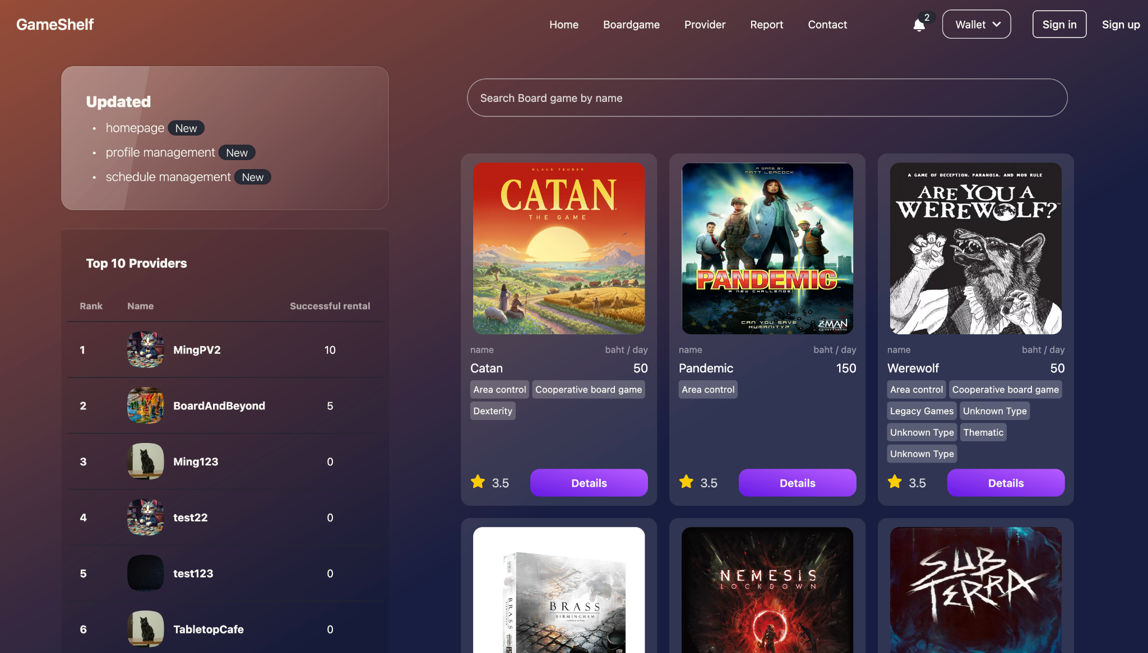

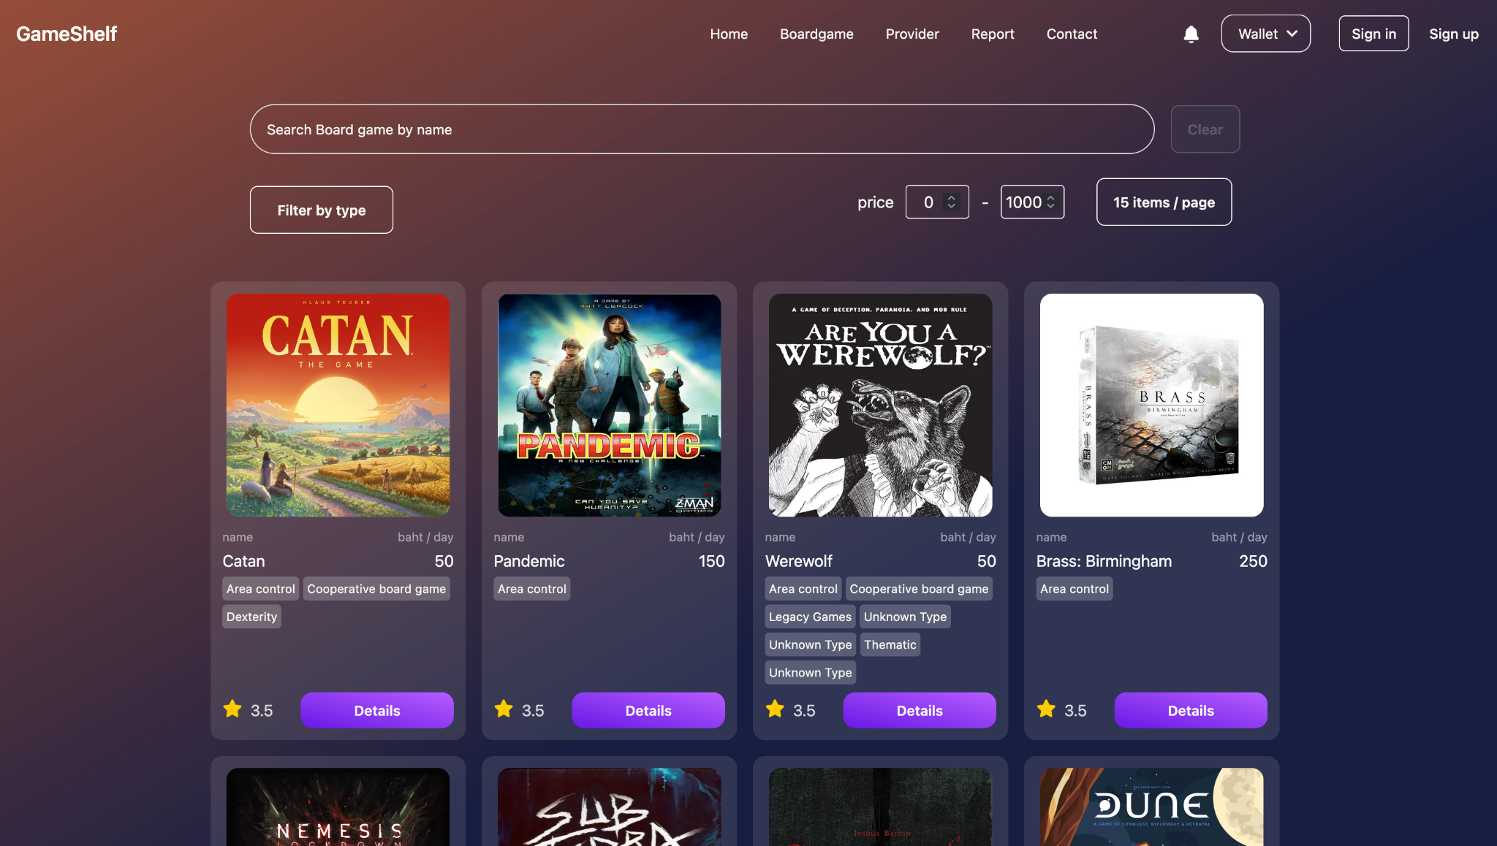

1. At providers search user can go to provider’s profile to see the details about that provider

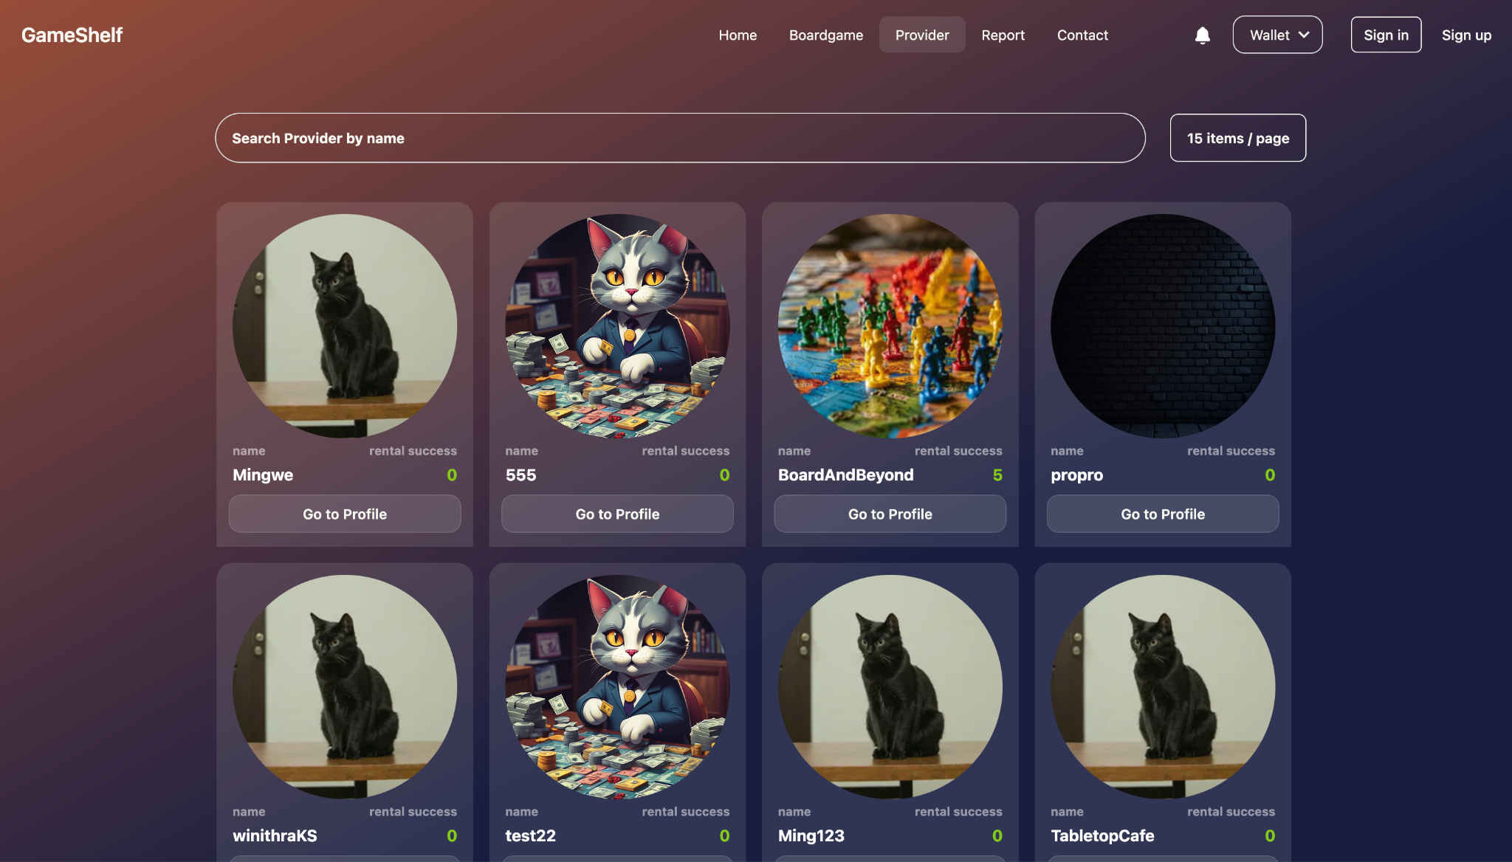

1. Users can rent the board game by picking one of the board games on the provider's profile.

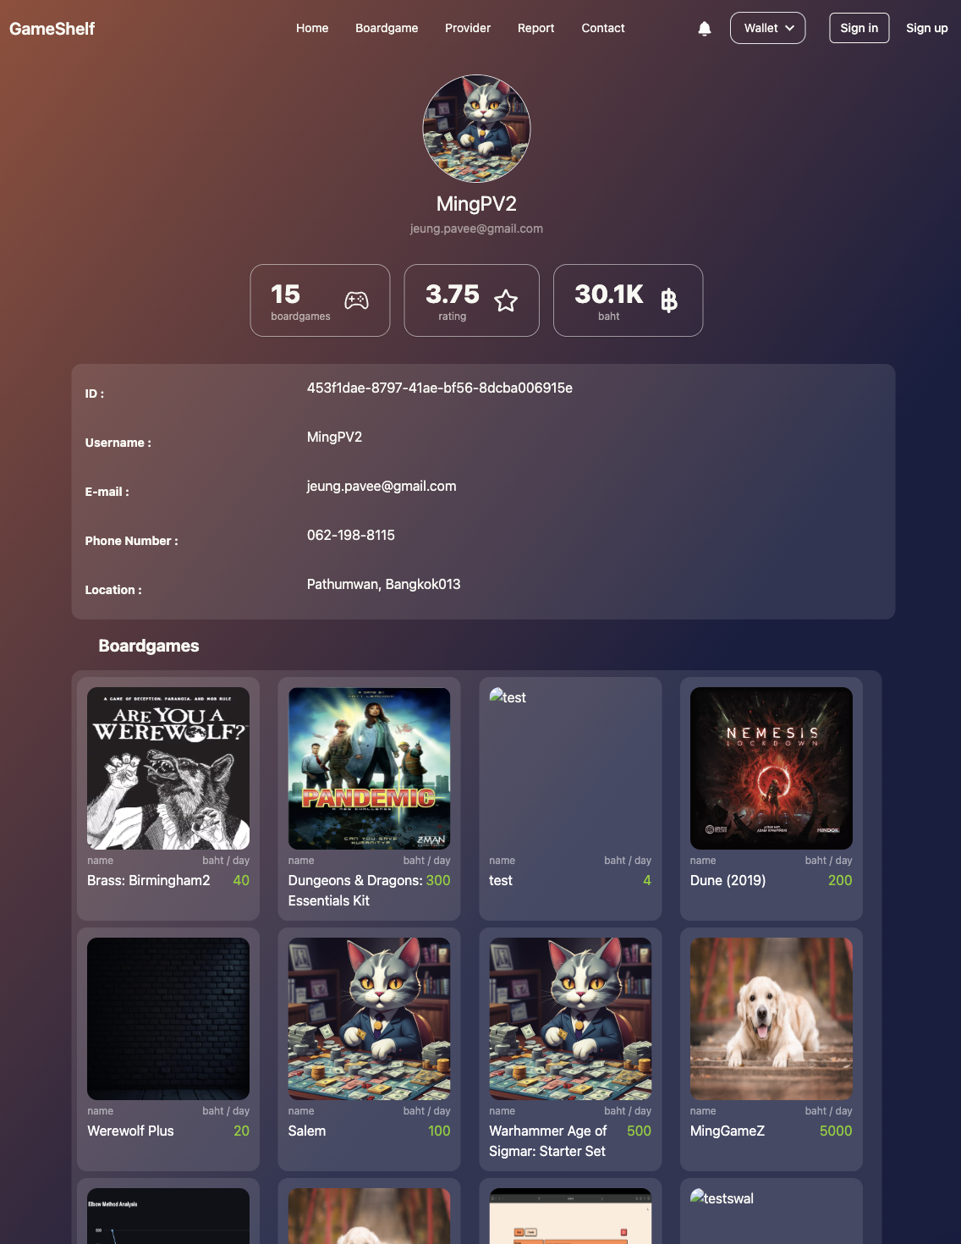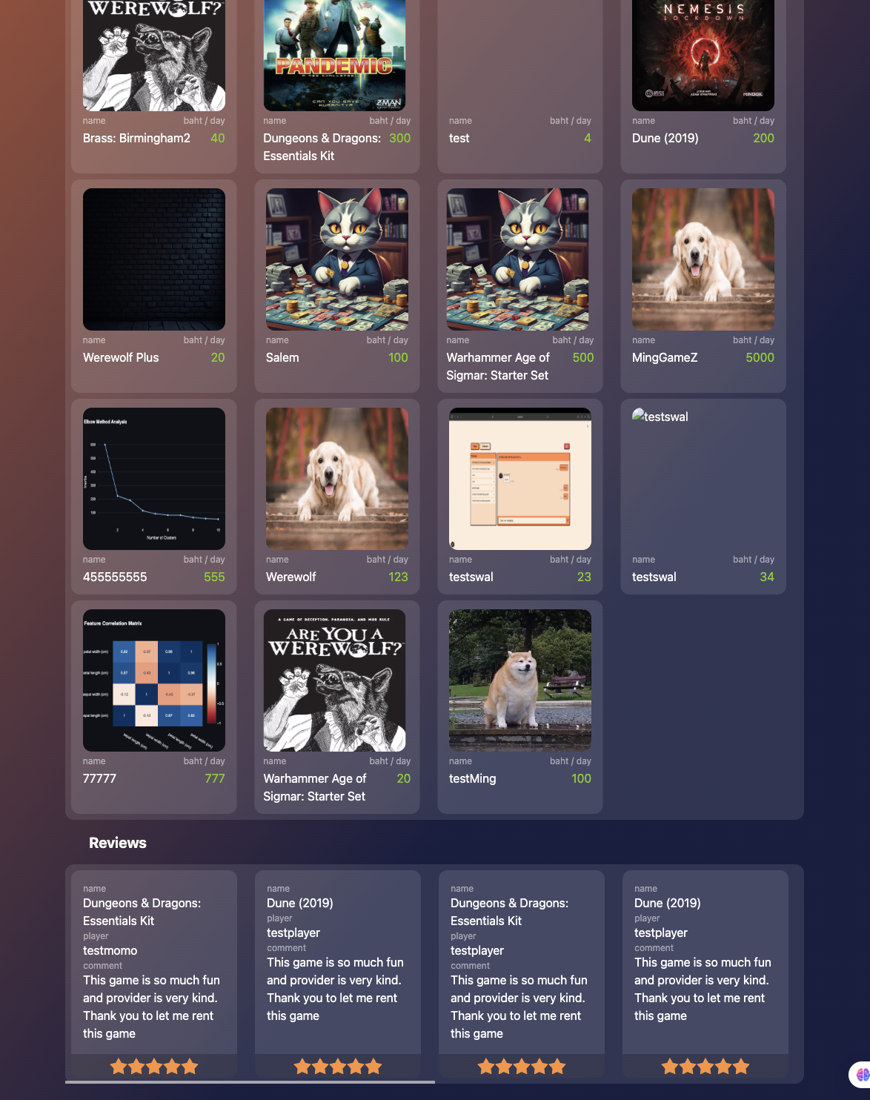

## Function : Register / Login

Role : Player , Provider , Admin

**Instruction**

1. Users can click Sign-in/Sign-up on the navbar to go to the Sign-up/Sign-in page.

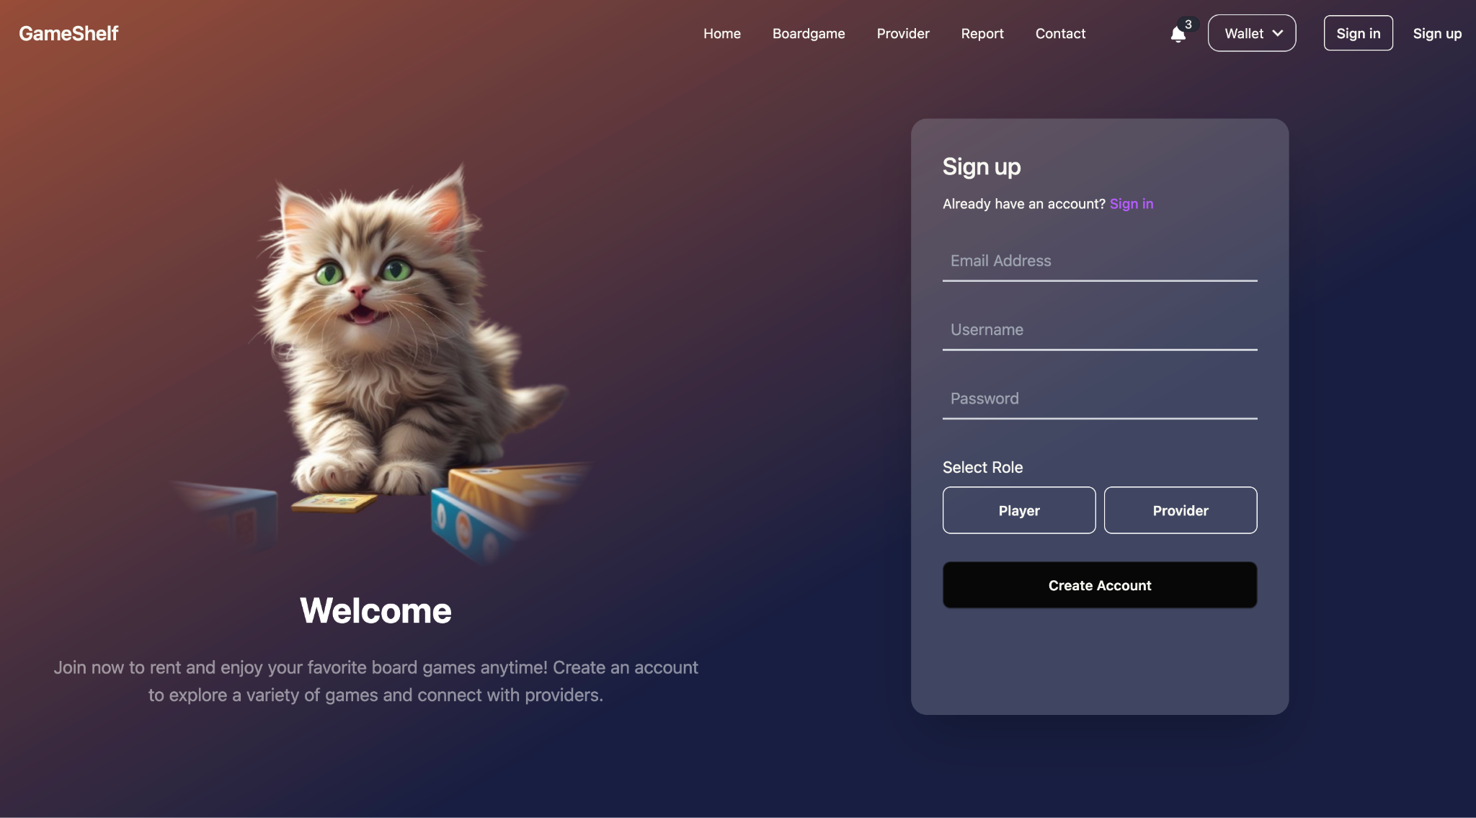

1. User fill the form and then select the role (Provider / Player)

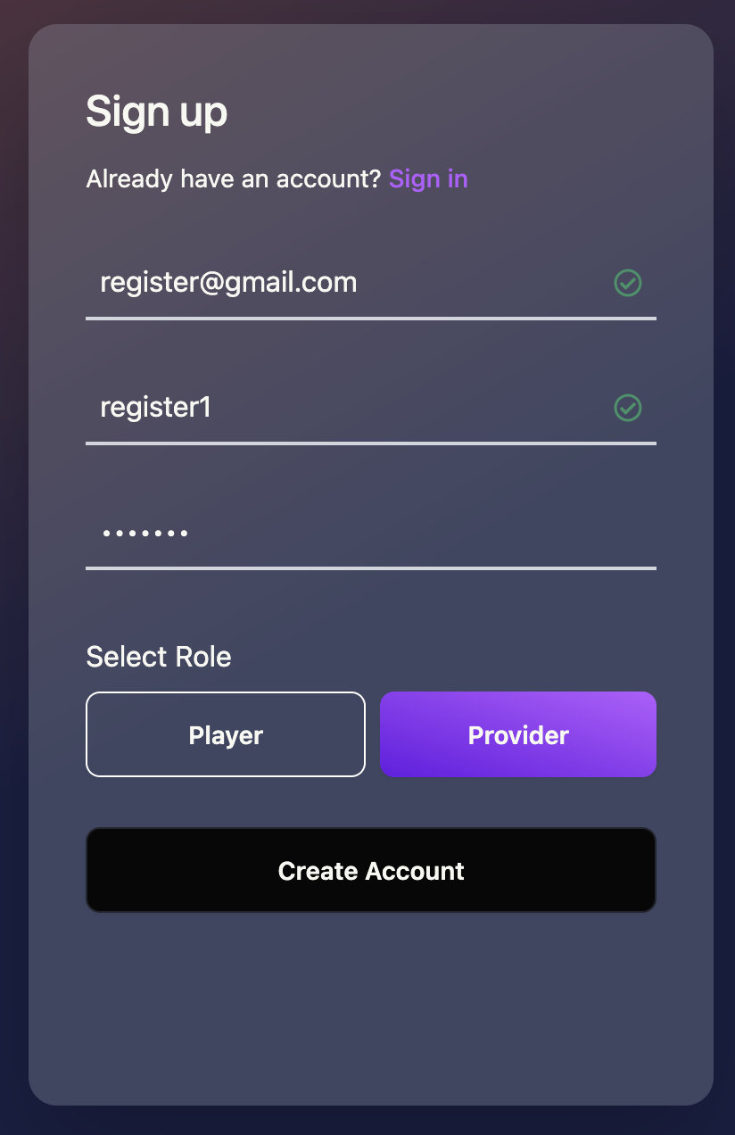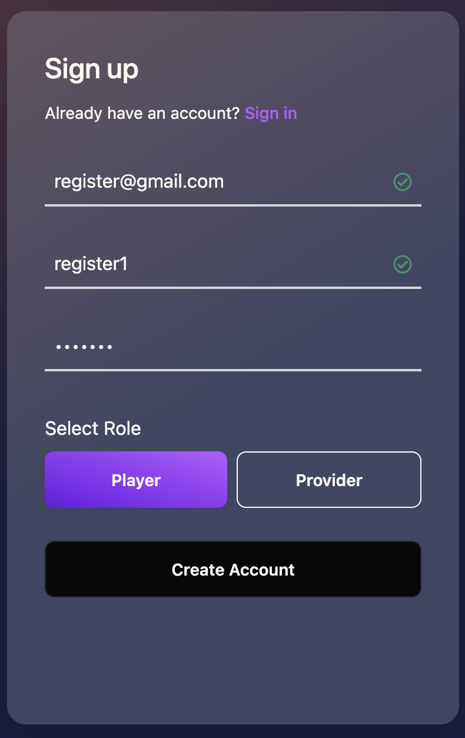

1. After the Sign-up user can sign-in at the sign-in page and when the password or email is not correct, the user will see the error message at the bottom.

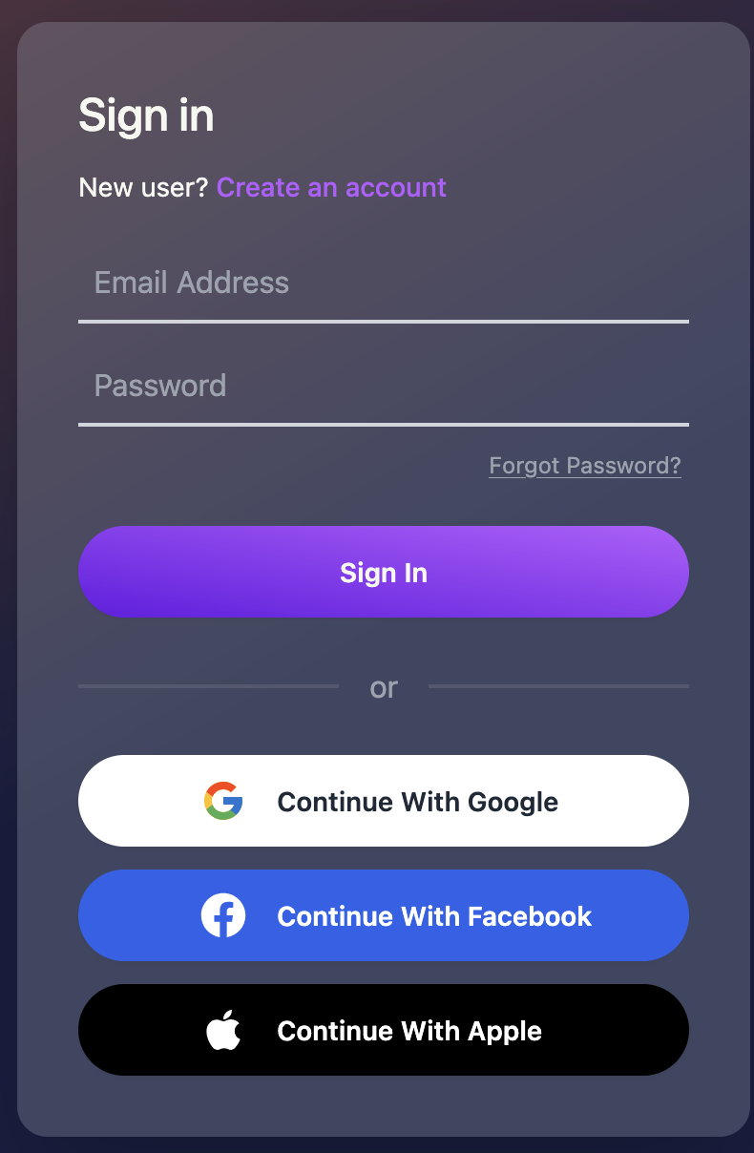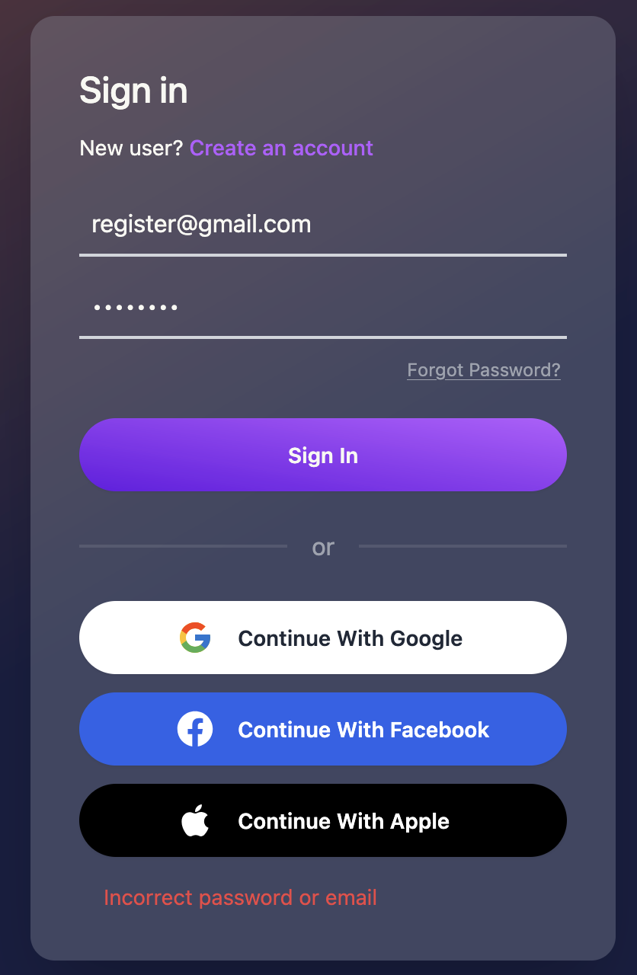

## Function : Profile Settings

Role : Player , Provider , Admin

**Instruction**

1. Users can go to profile settings at user profile in the navbar.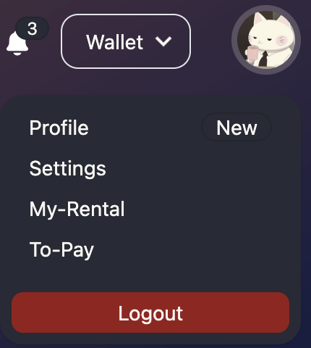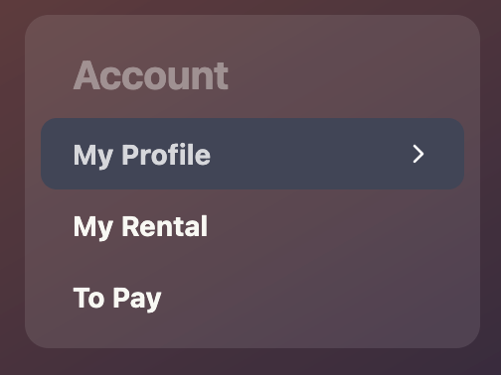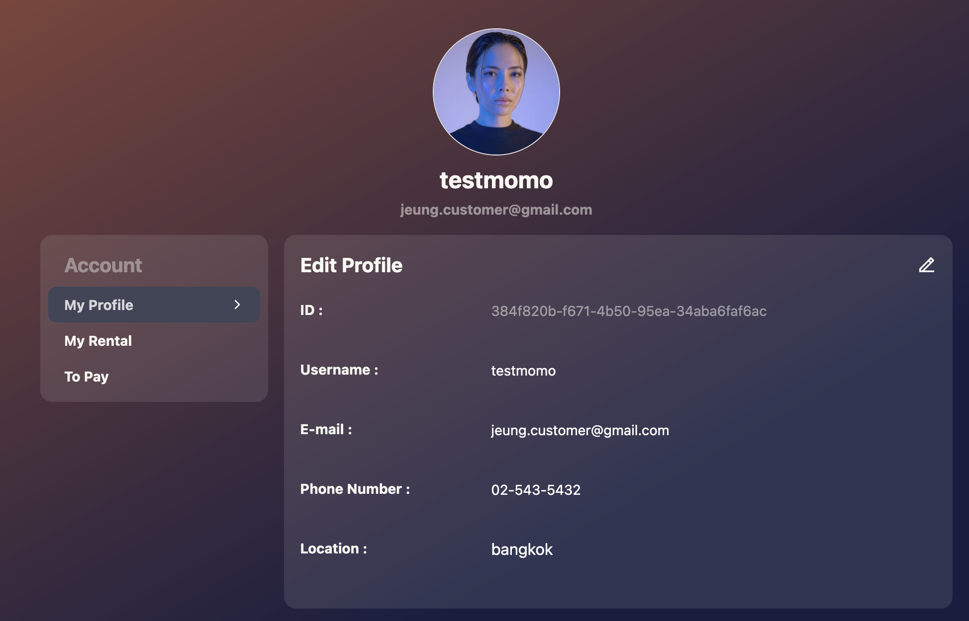
2. Users can edit their profile by clicking on the pencil icon on the top of the details.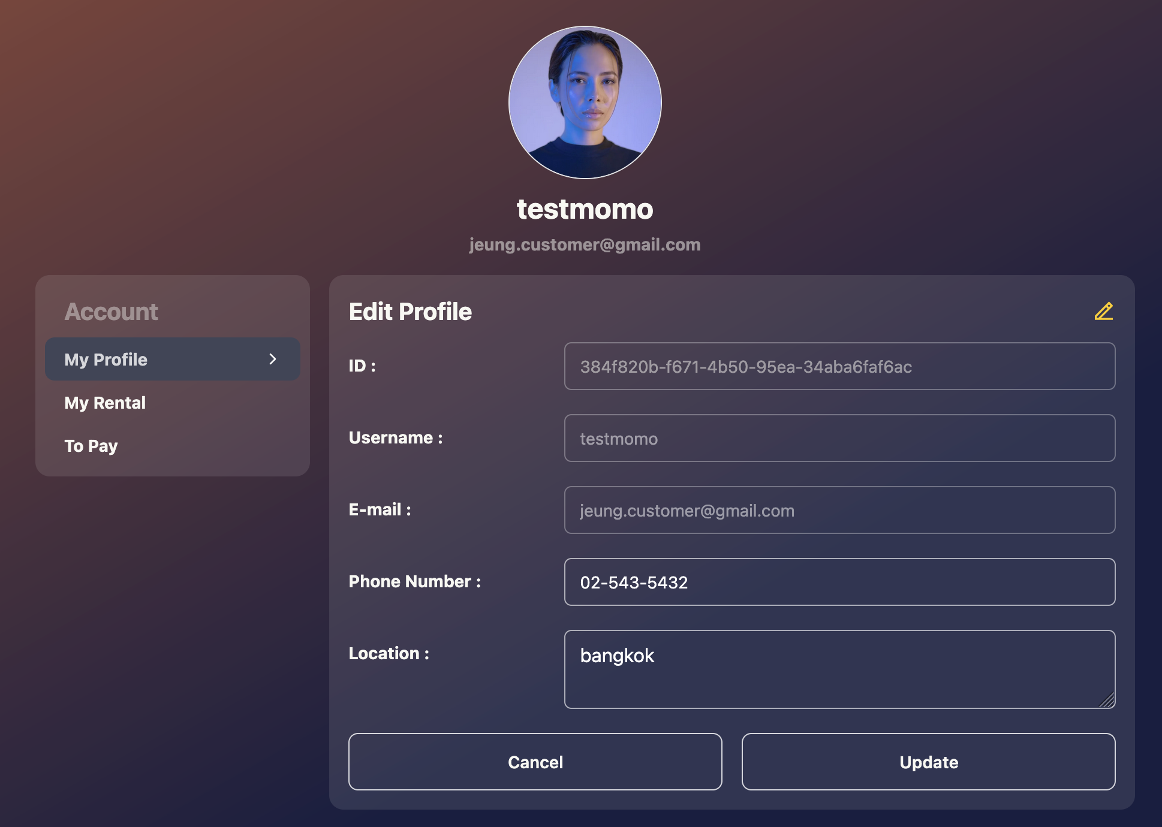

## Function : Send rental request

Role : Player

**Instruction**

1. Users can see the details of the board game by clicking on the detail button.

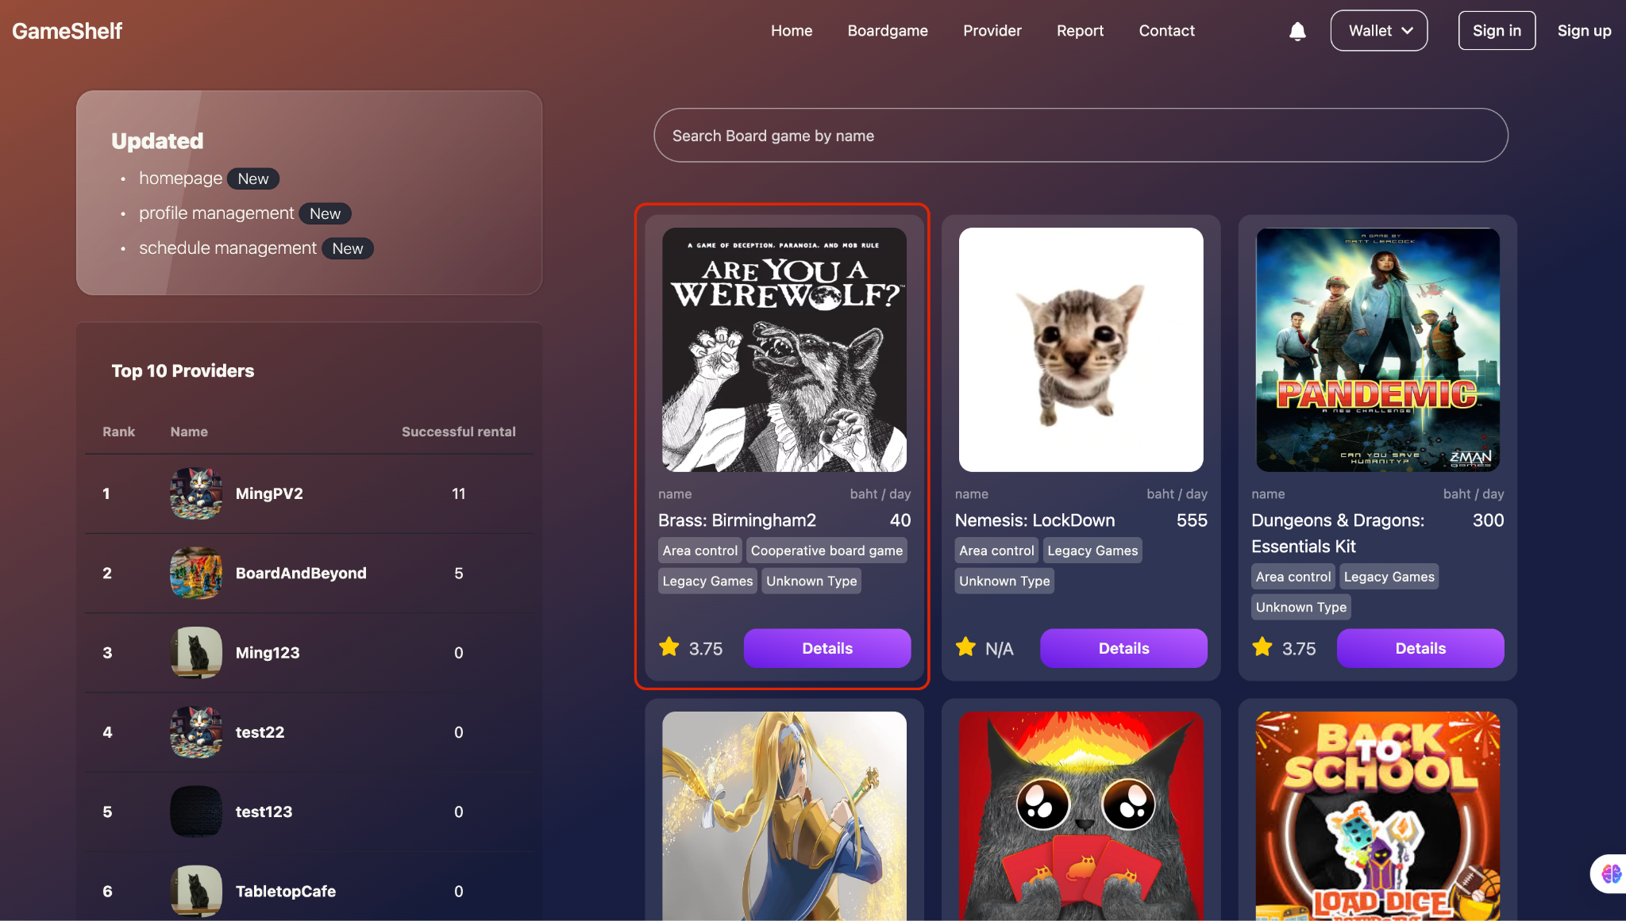

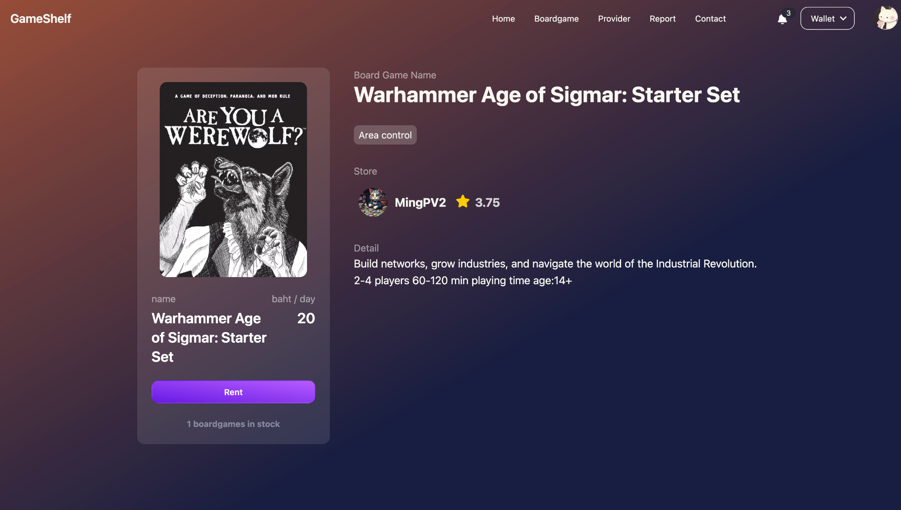

1. Users can send the request by selecting the start date and end date of the rental.

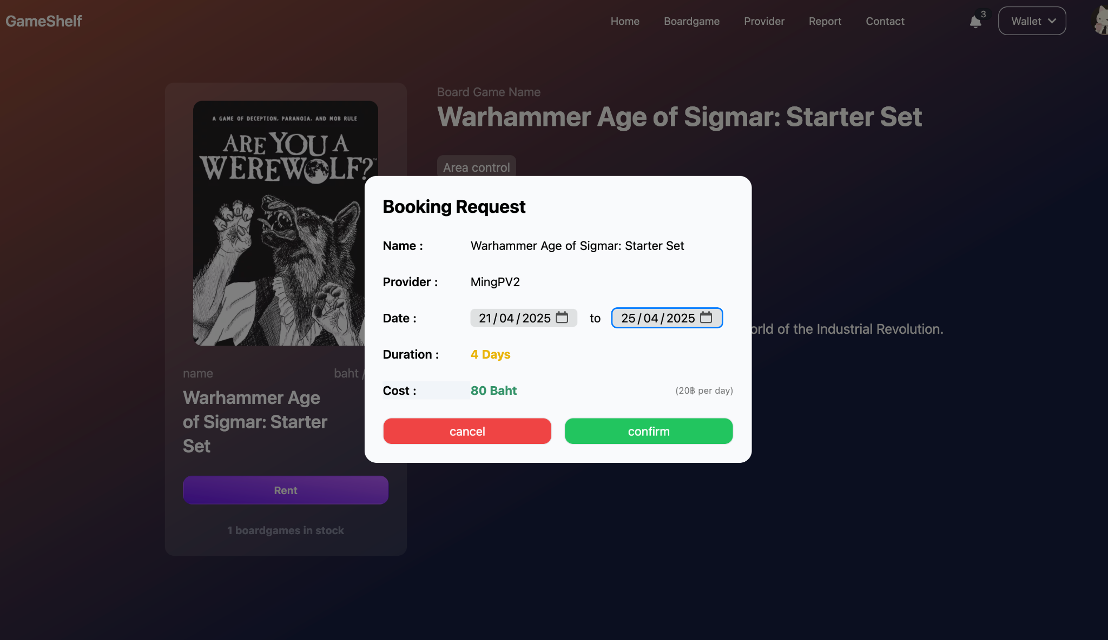

## Function : Pay the rental

Role : Player

**Instruction**

1. Users can see the list of to-pay rental requests at the To-Pay page.

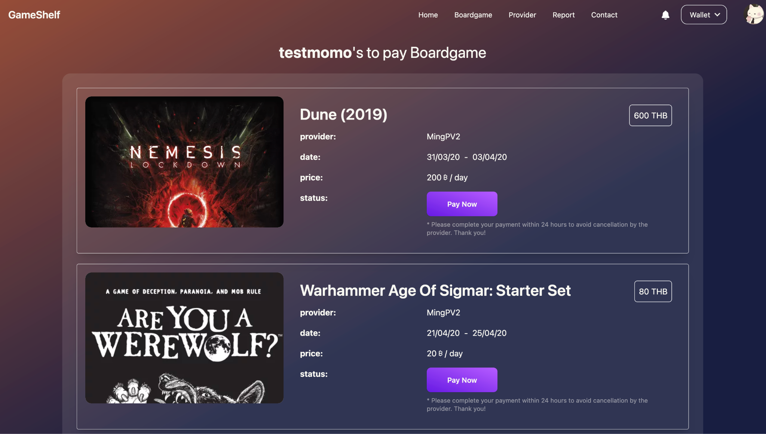

1. When clicking on the Pay Now button user will be redirected to payment page

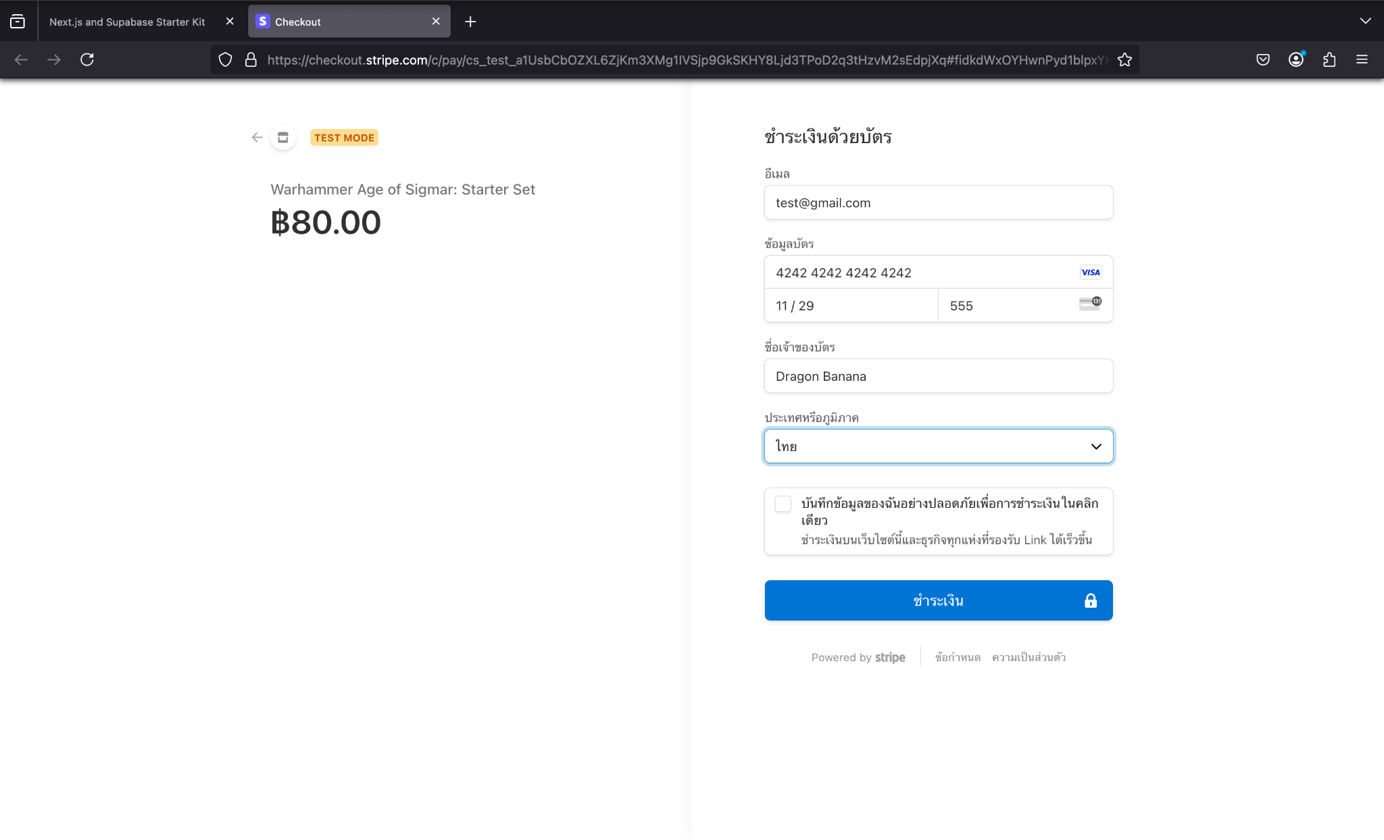

## Function : Check rental status

Role : Player

**Instruction**

1. Users can check the status of the rental at My-Rental page. This page will show the status such as complete, cancelled, renting , pending , unpaid.

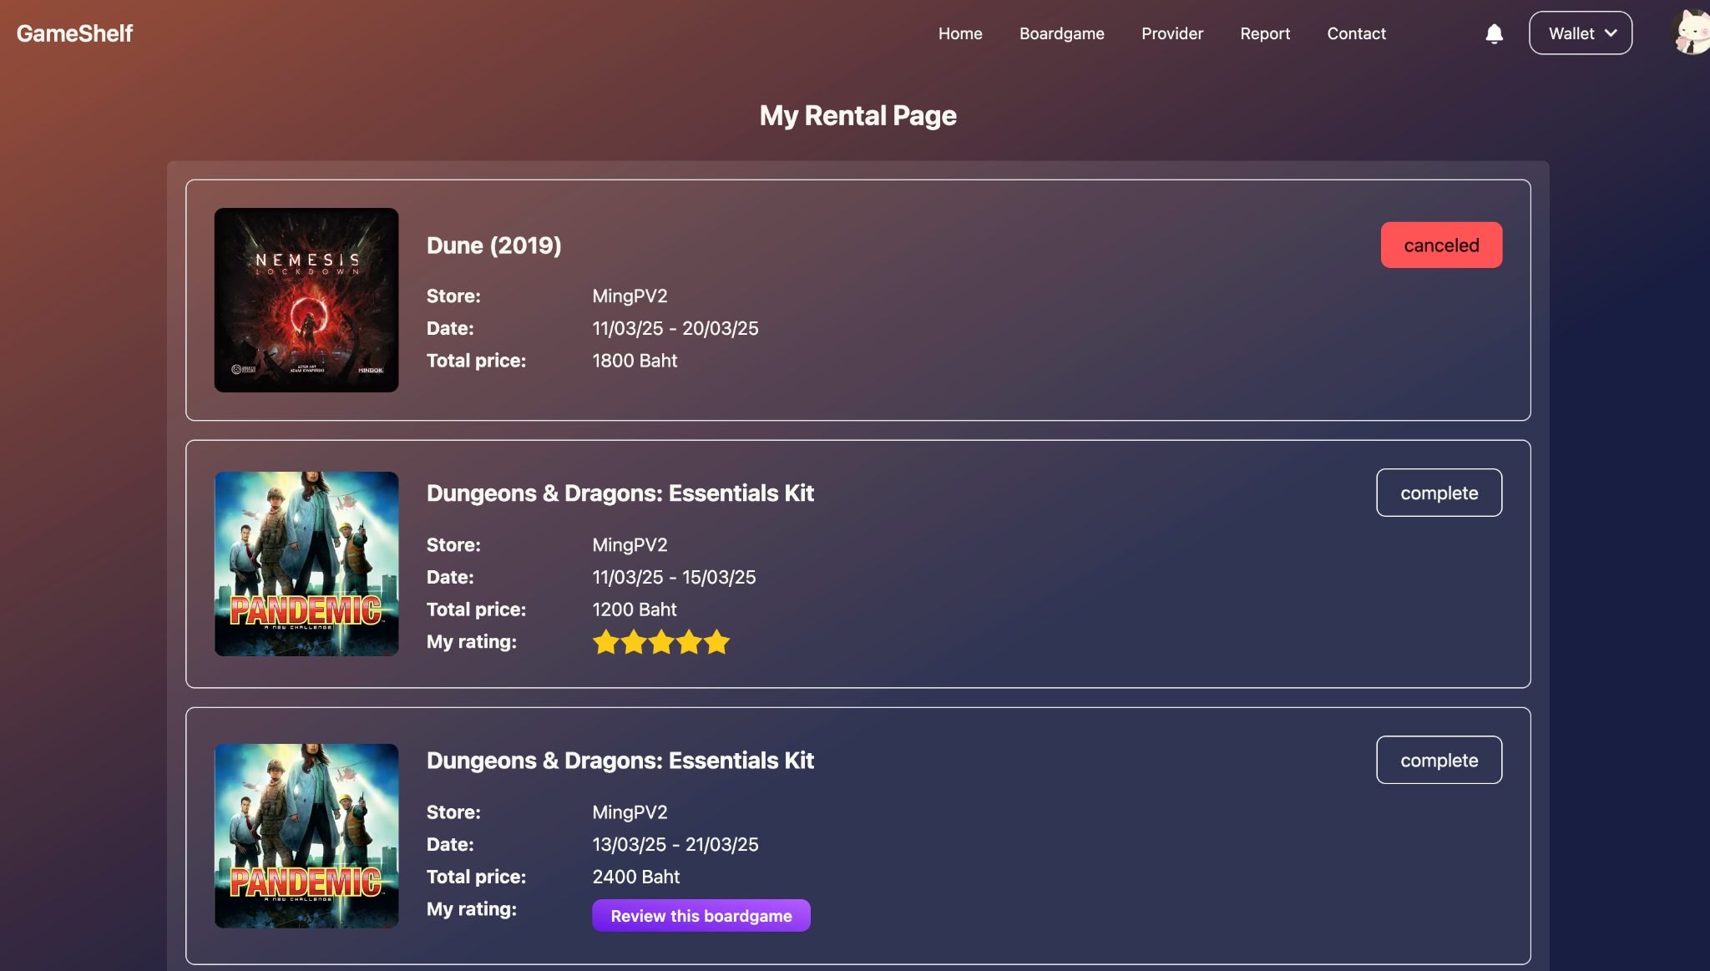

## Function : Add picture when Receive / Return board games

Role : Player

**Instruction**

1. After Receiving the board game user needs to add the picture after receiving the board game.

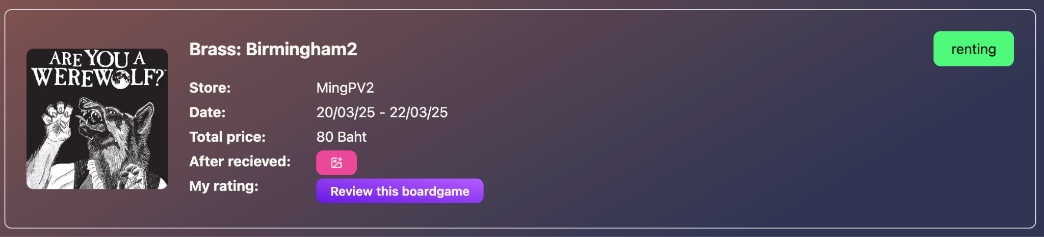

1. Before returning the board game user needs to add the picture before returning the boardgame.

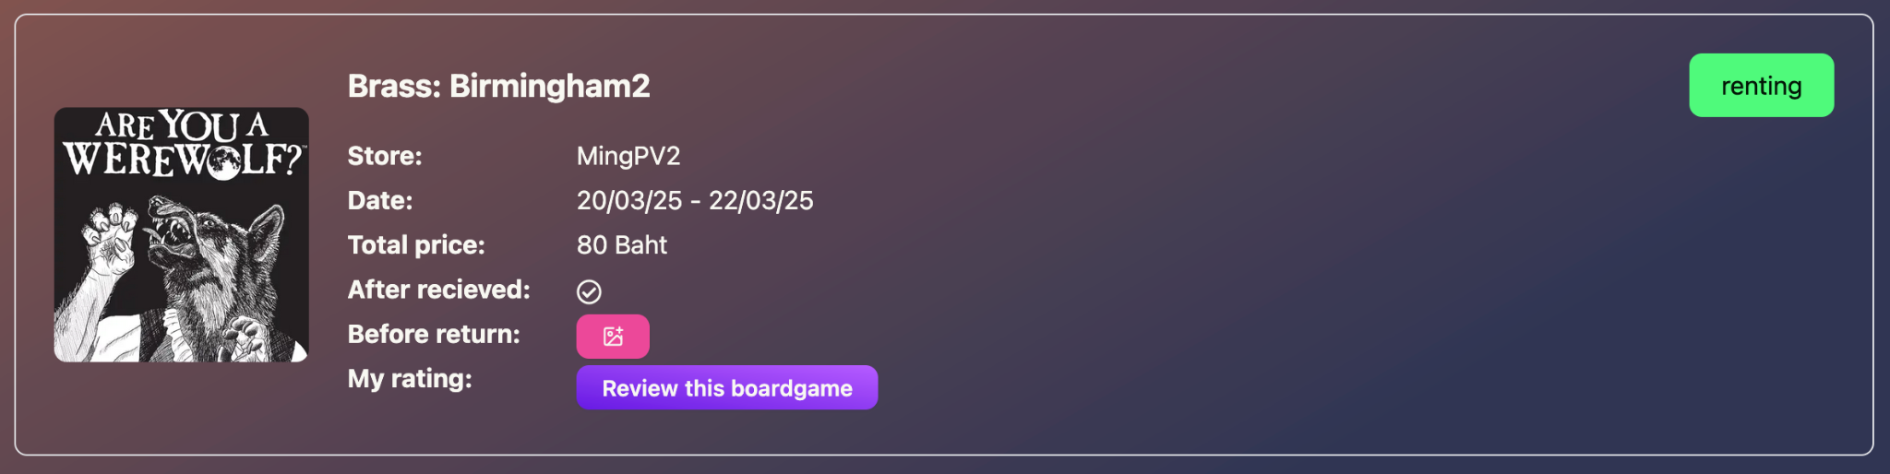

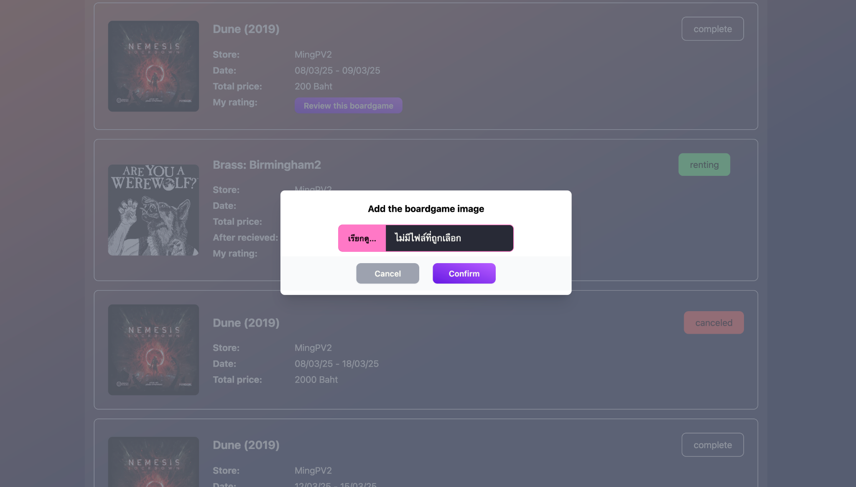

## Function : Review board games

Role : Player

**Instruction**

1. Users can review board games at the My-Rental page at the profile menu.

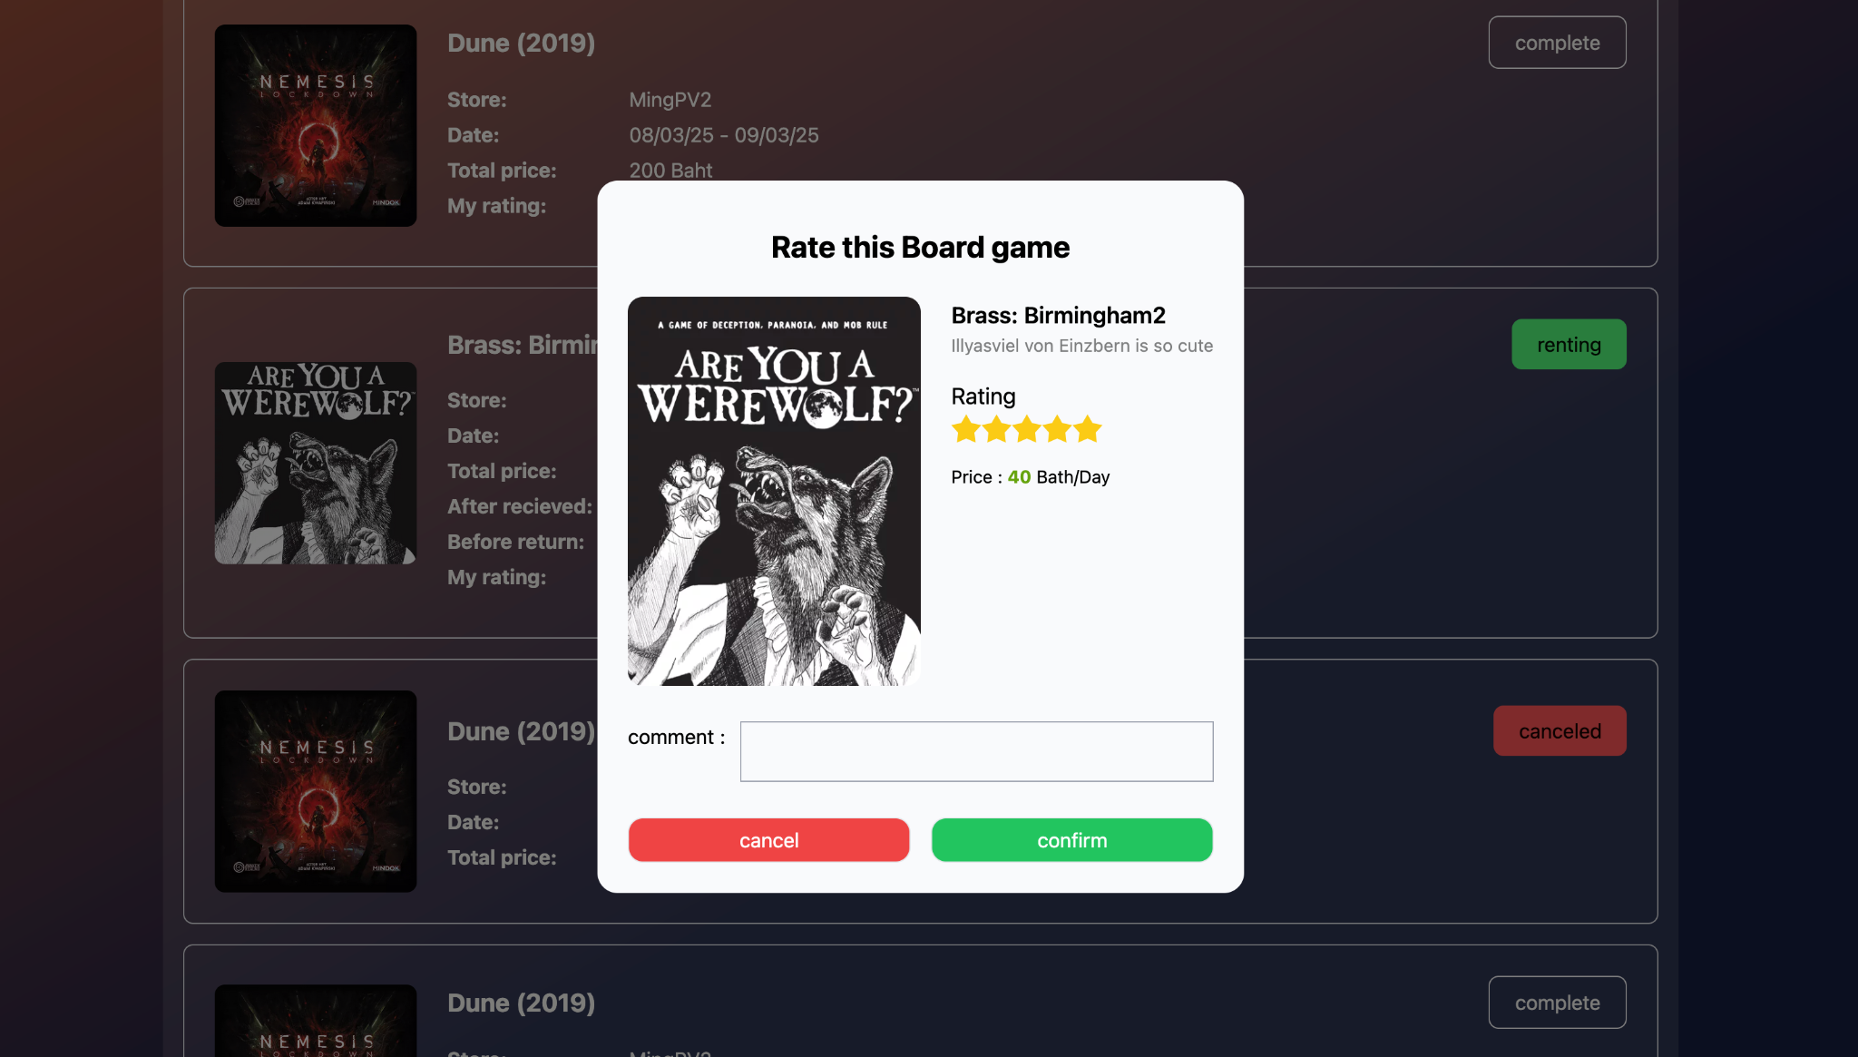

1. After reviewing the board game it will show the rating that you give to provider.

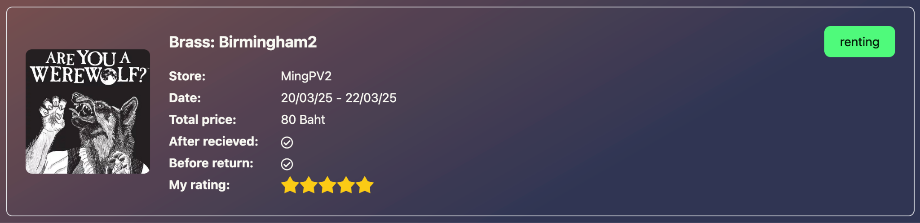

## Function : Report

Role : Player, Provider

**Instruction**

1. User can go to the report form by clicking report menu at the navbar
2. The report has 2 types, General to report for normal report and Rental for report by reference to your rental or if you are a provider it will reference to the rental that player rents to your board games.

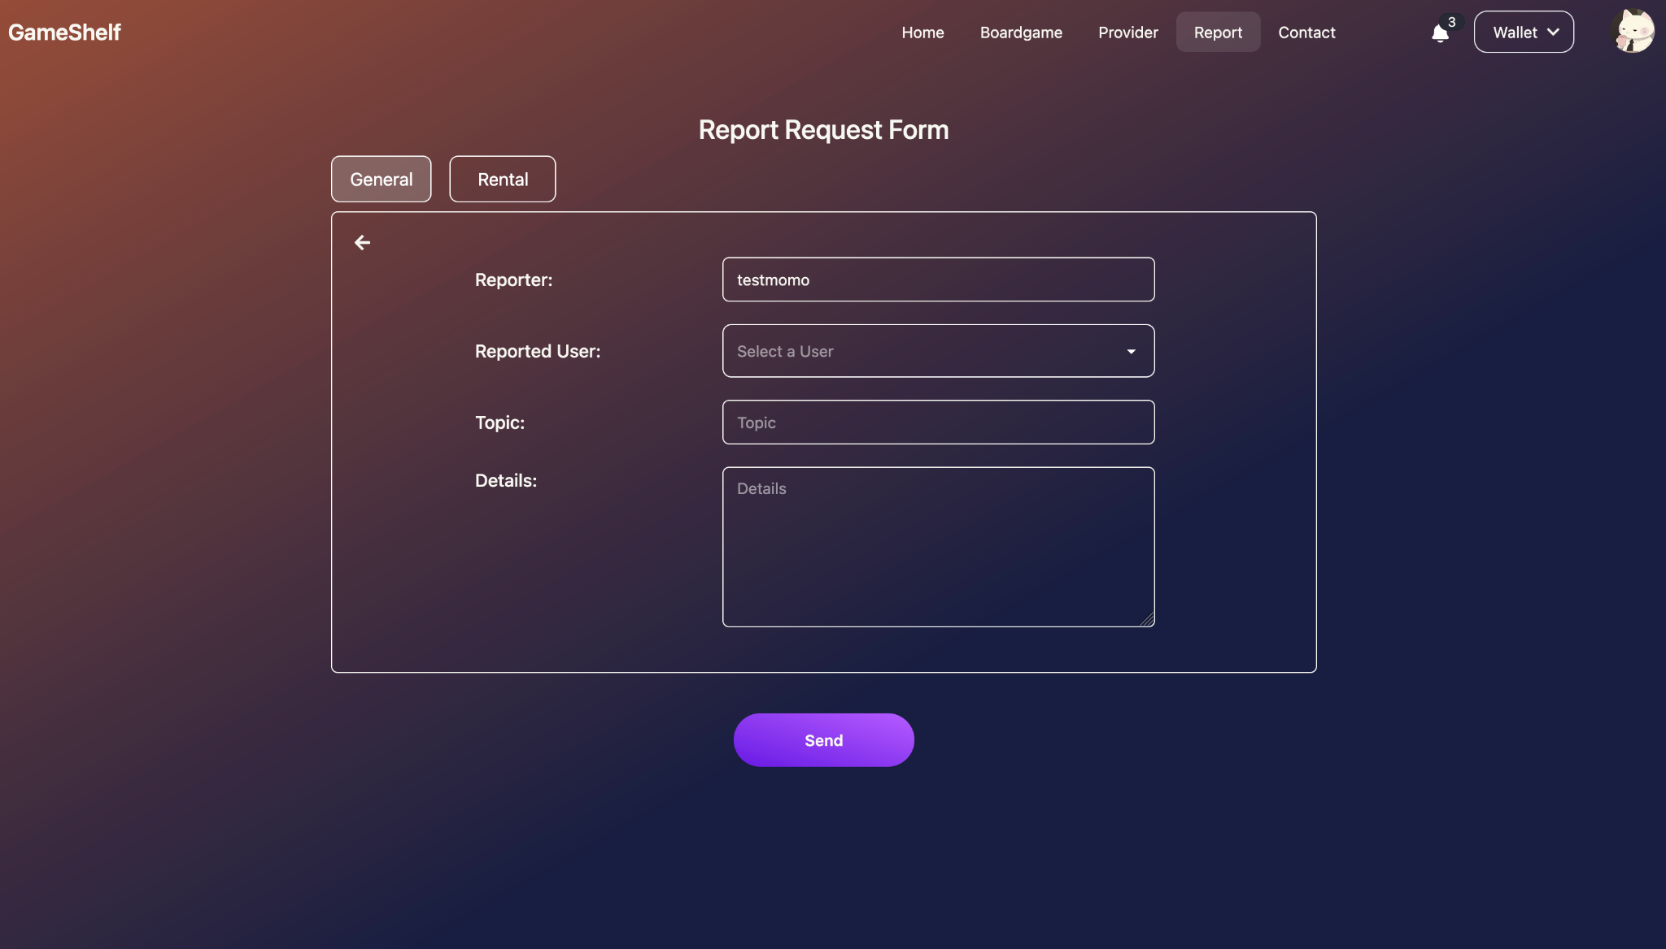

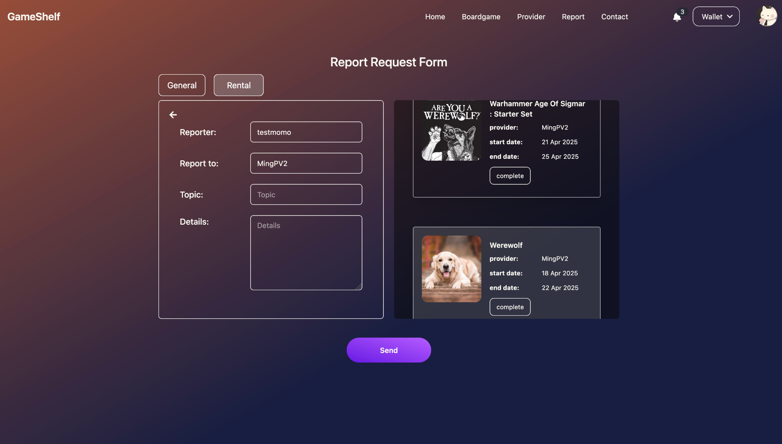

## Function : Notification

Role : Player, Provider

**Instruction**

1. Users can see the notifications on the navbar and when clicking see all it will navigate to the full notifications page.

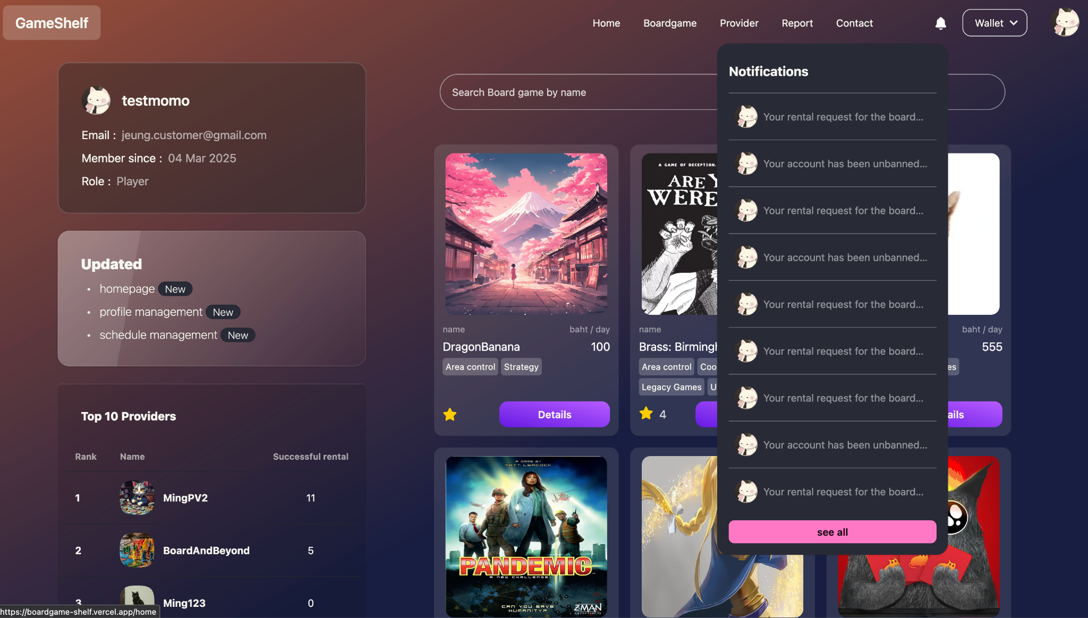

1. Users can see the details of each notification when being in the notification page.

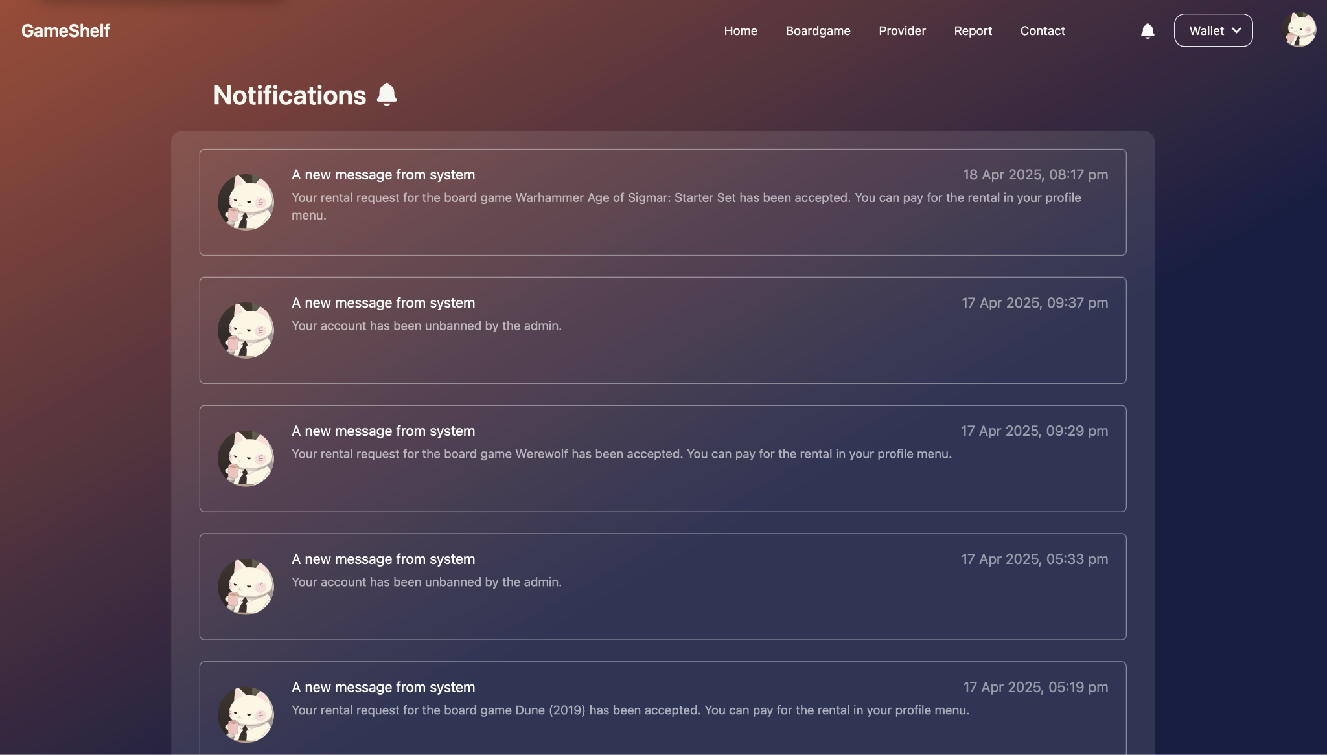

## Function : Provider verification

Role : Provider

**Instruction**

1. After sign-up as a provider, the user will see the verification button at the homepage.

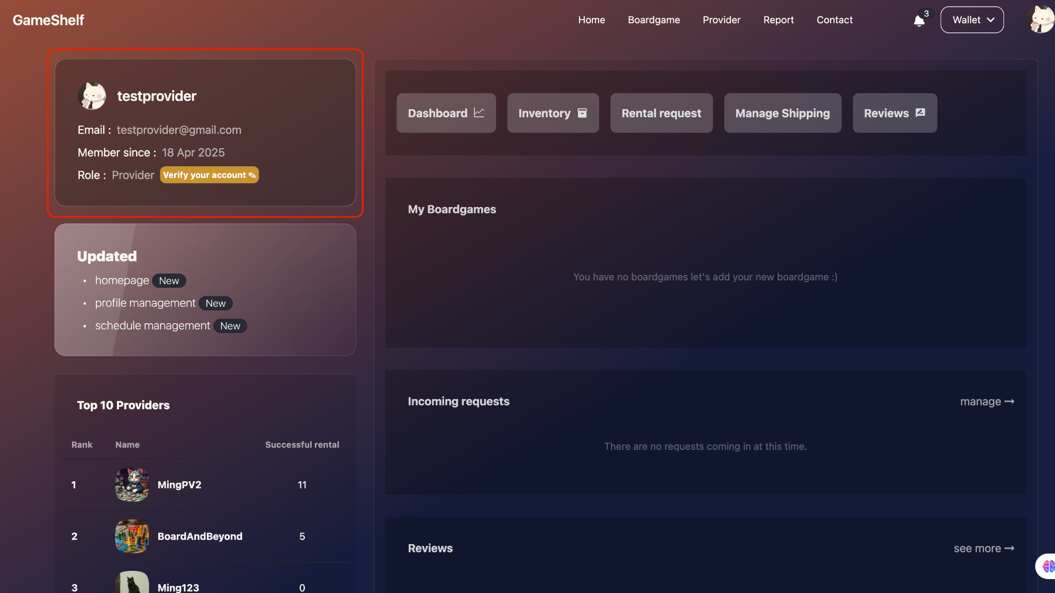

1. Fill the form to send the request to the administrator to verify your data.

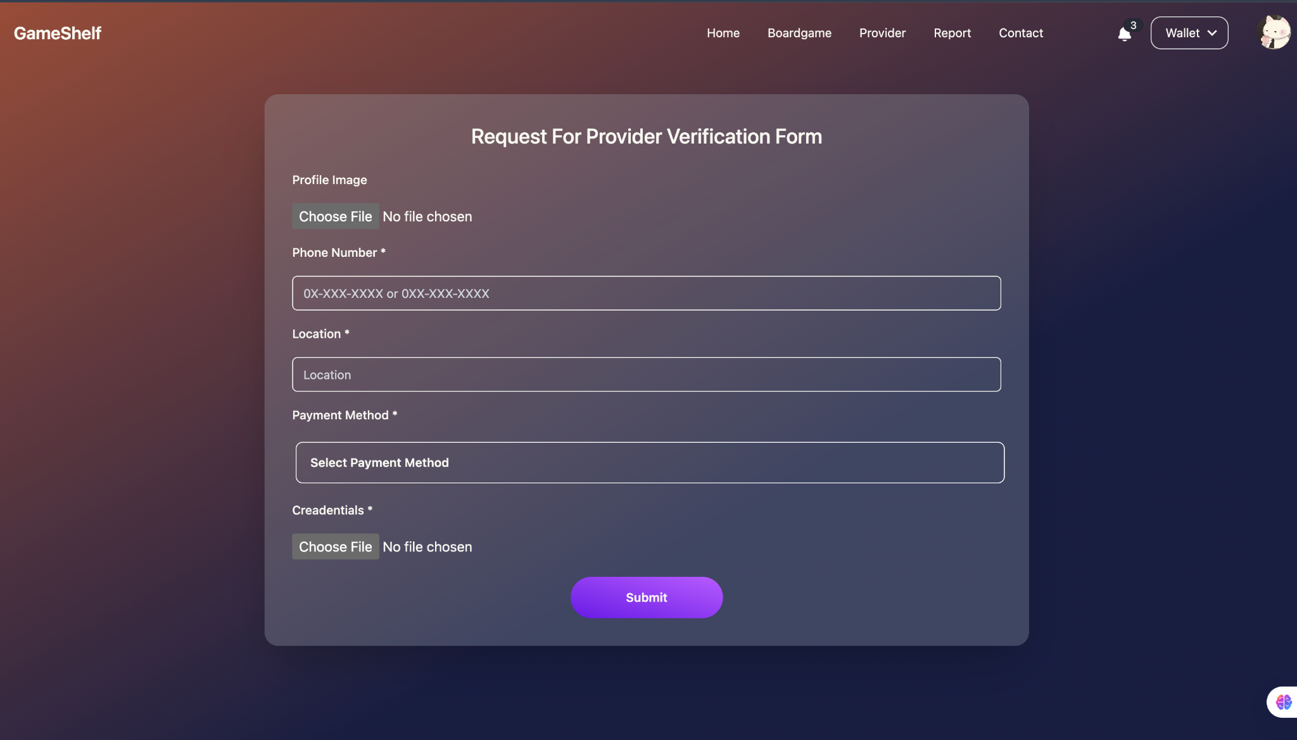

1. Users will see the status of verification at the profile card after sending the request.

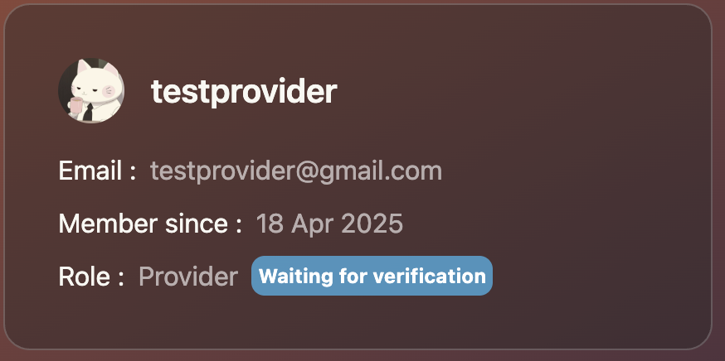

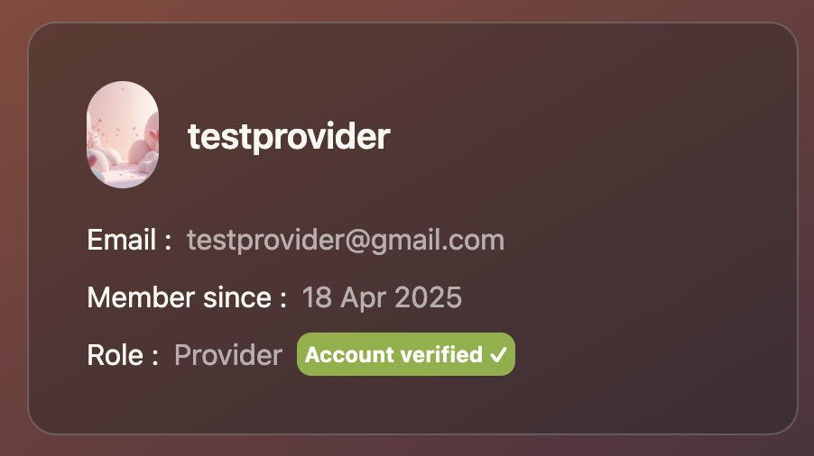

## Function : Add board game

Role : Provider

**Instruction**

1. Users can add board game at their profile settings by going to Inventory page

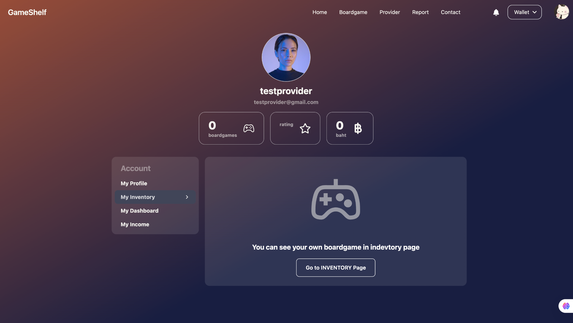

1. Click add new boardgame

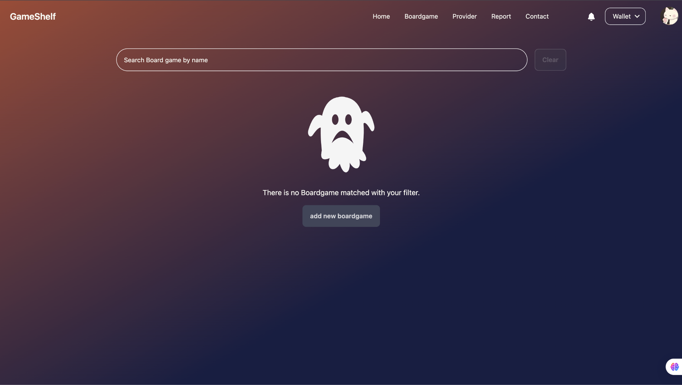

1. Fill the board game details and then click Add game

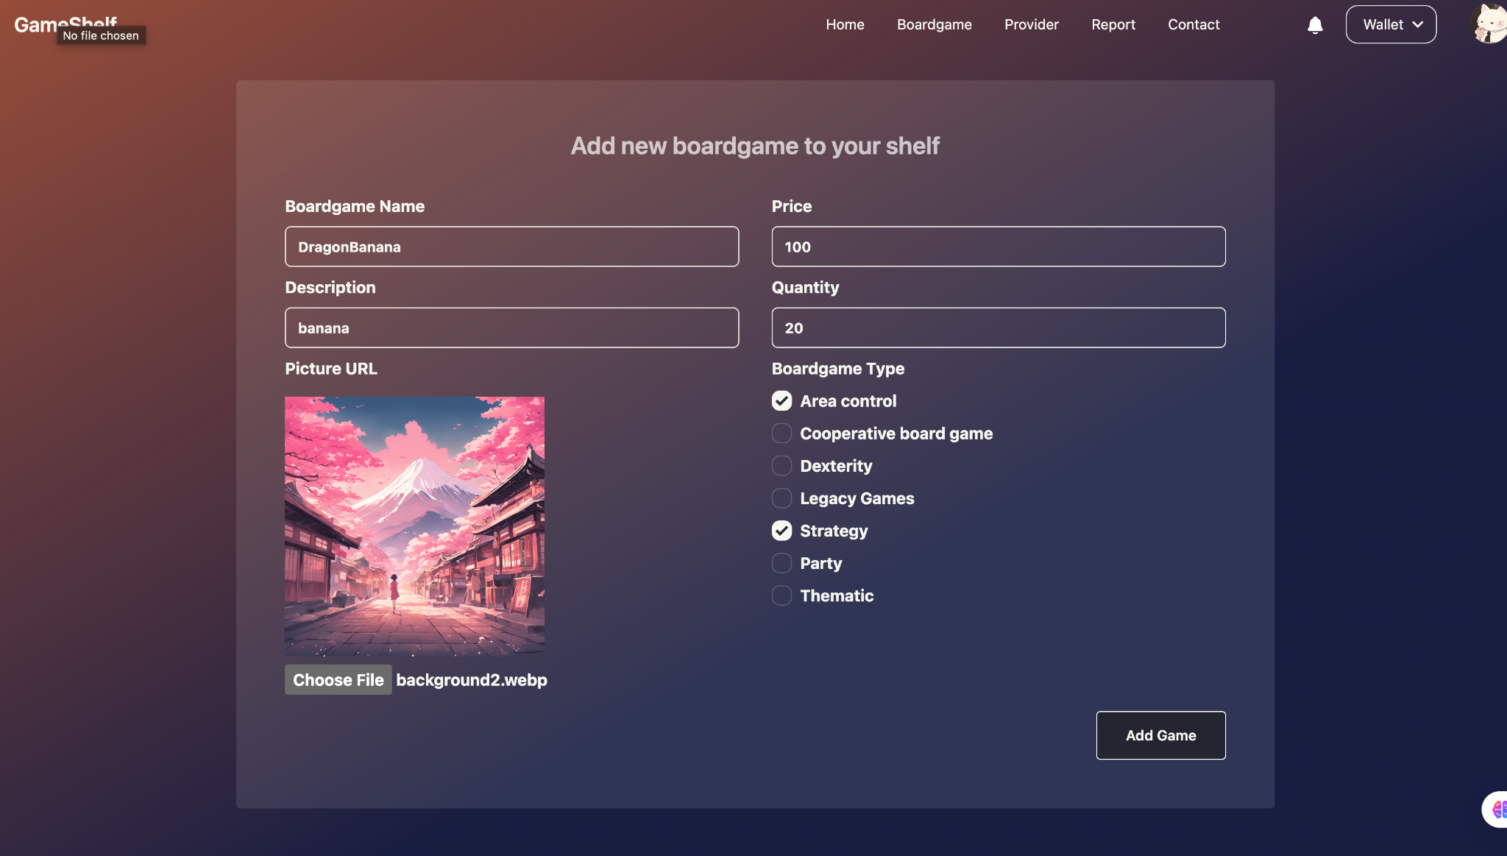

1. After add the boardgame, board game will be showed at the homepage and showed in search board game

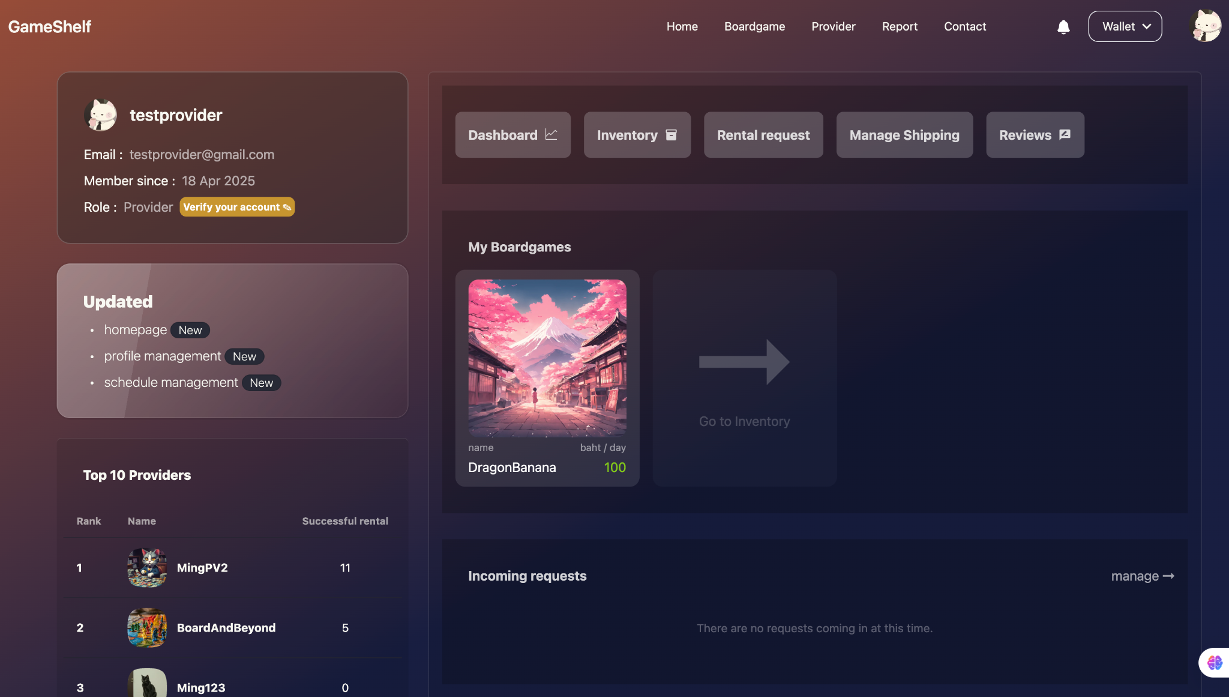

## Function : Manage rental request

Role : Provider

**Instruction**

1. Users will see the request in the provider homepage and can manage it by clicking the manage button to go to the manage page.

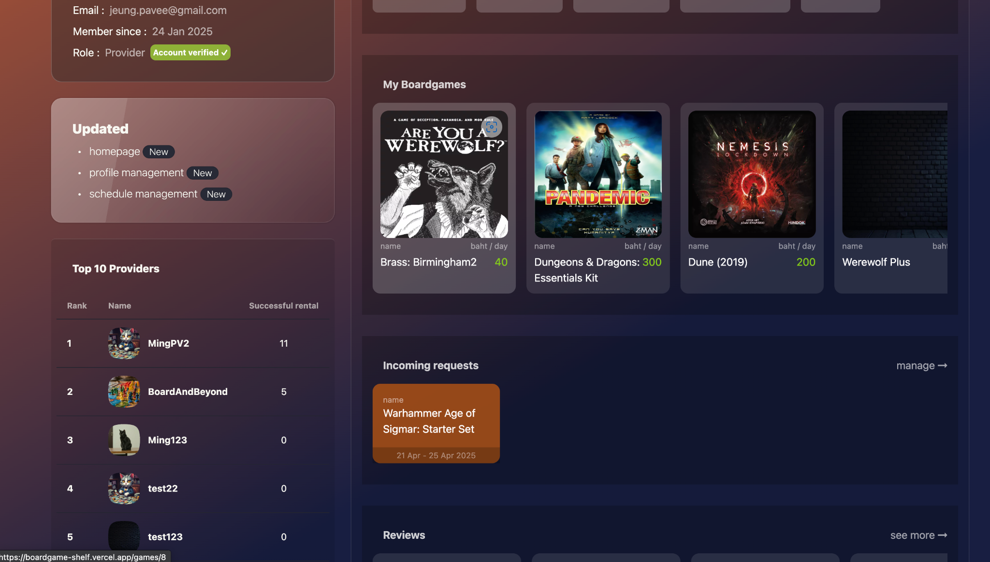

1. Users can click on the request to see the details of the rental request to make a decision

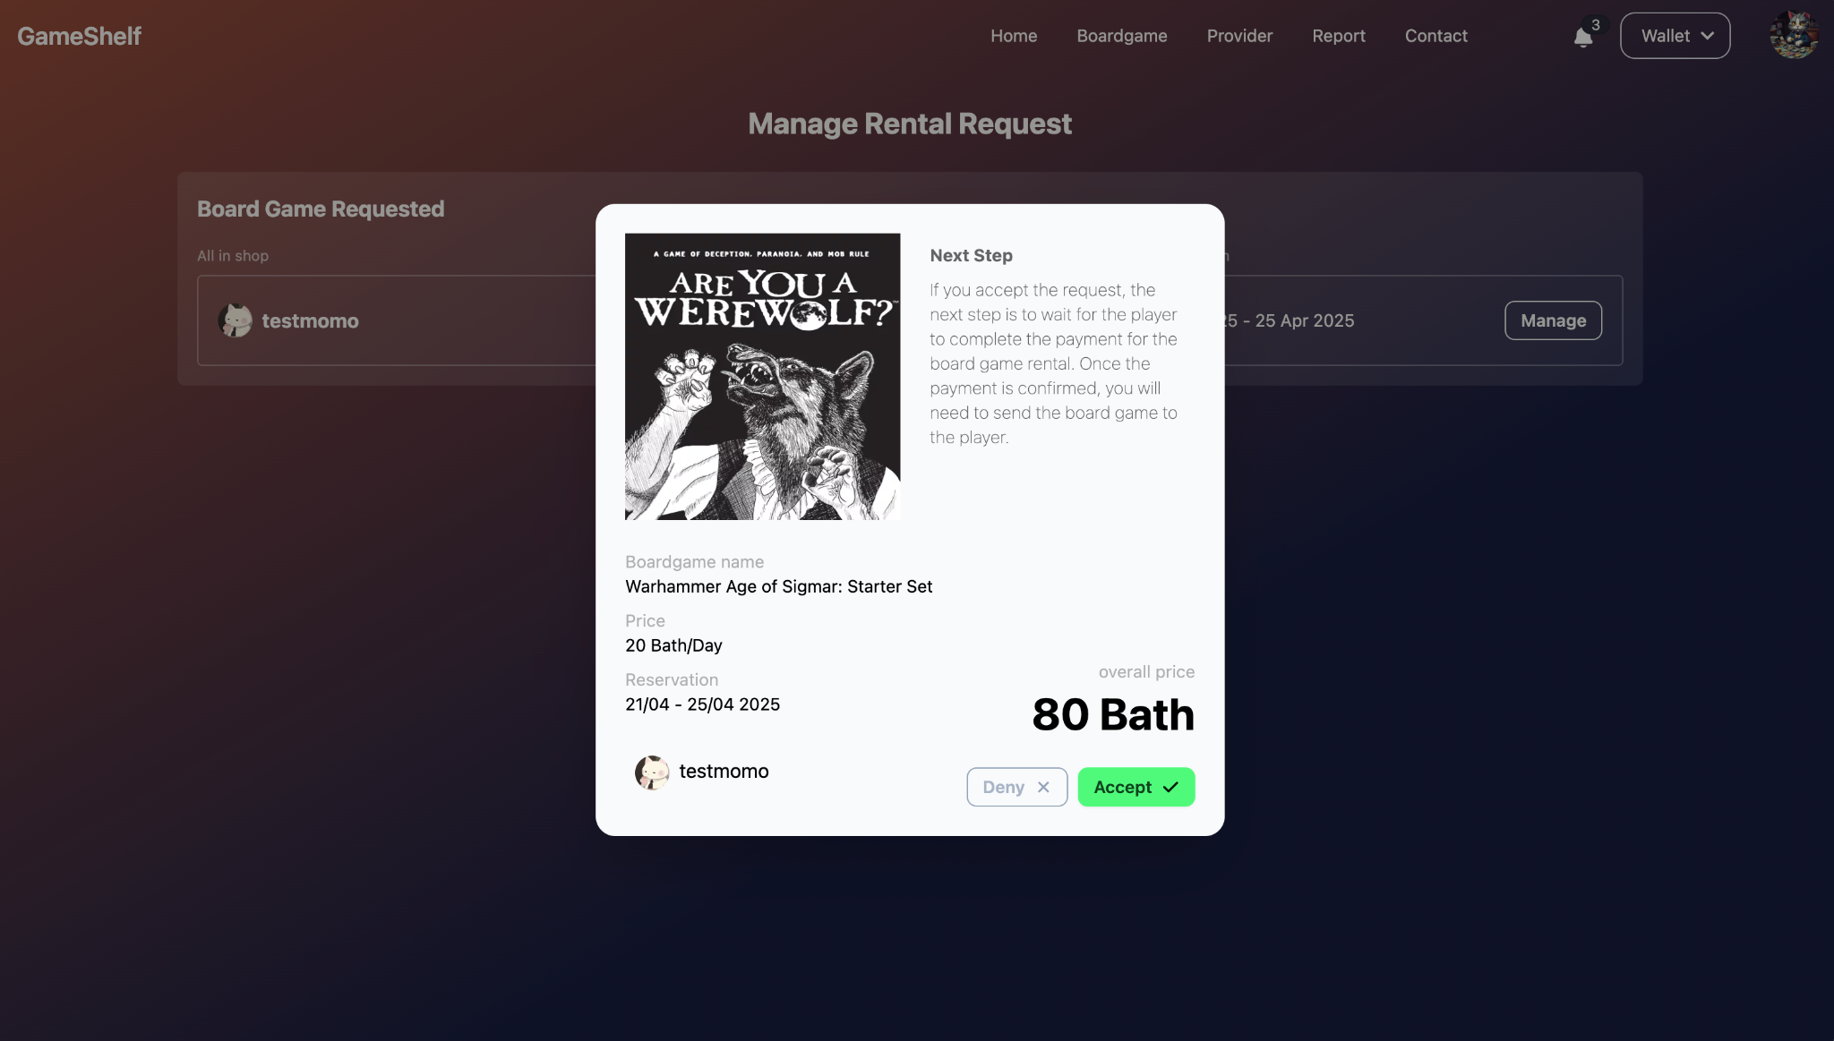

## Function : Manage shipping

Role : Provider

**Instruction**

1. Providers can manage their shipping status at shipping-page

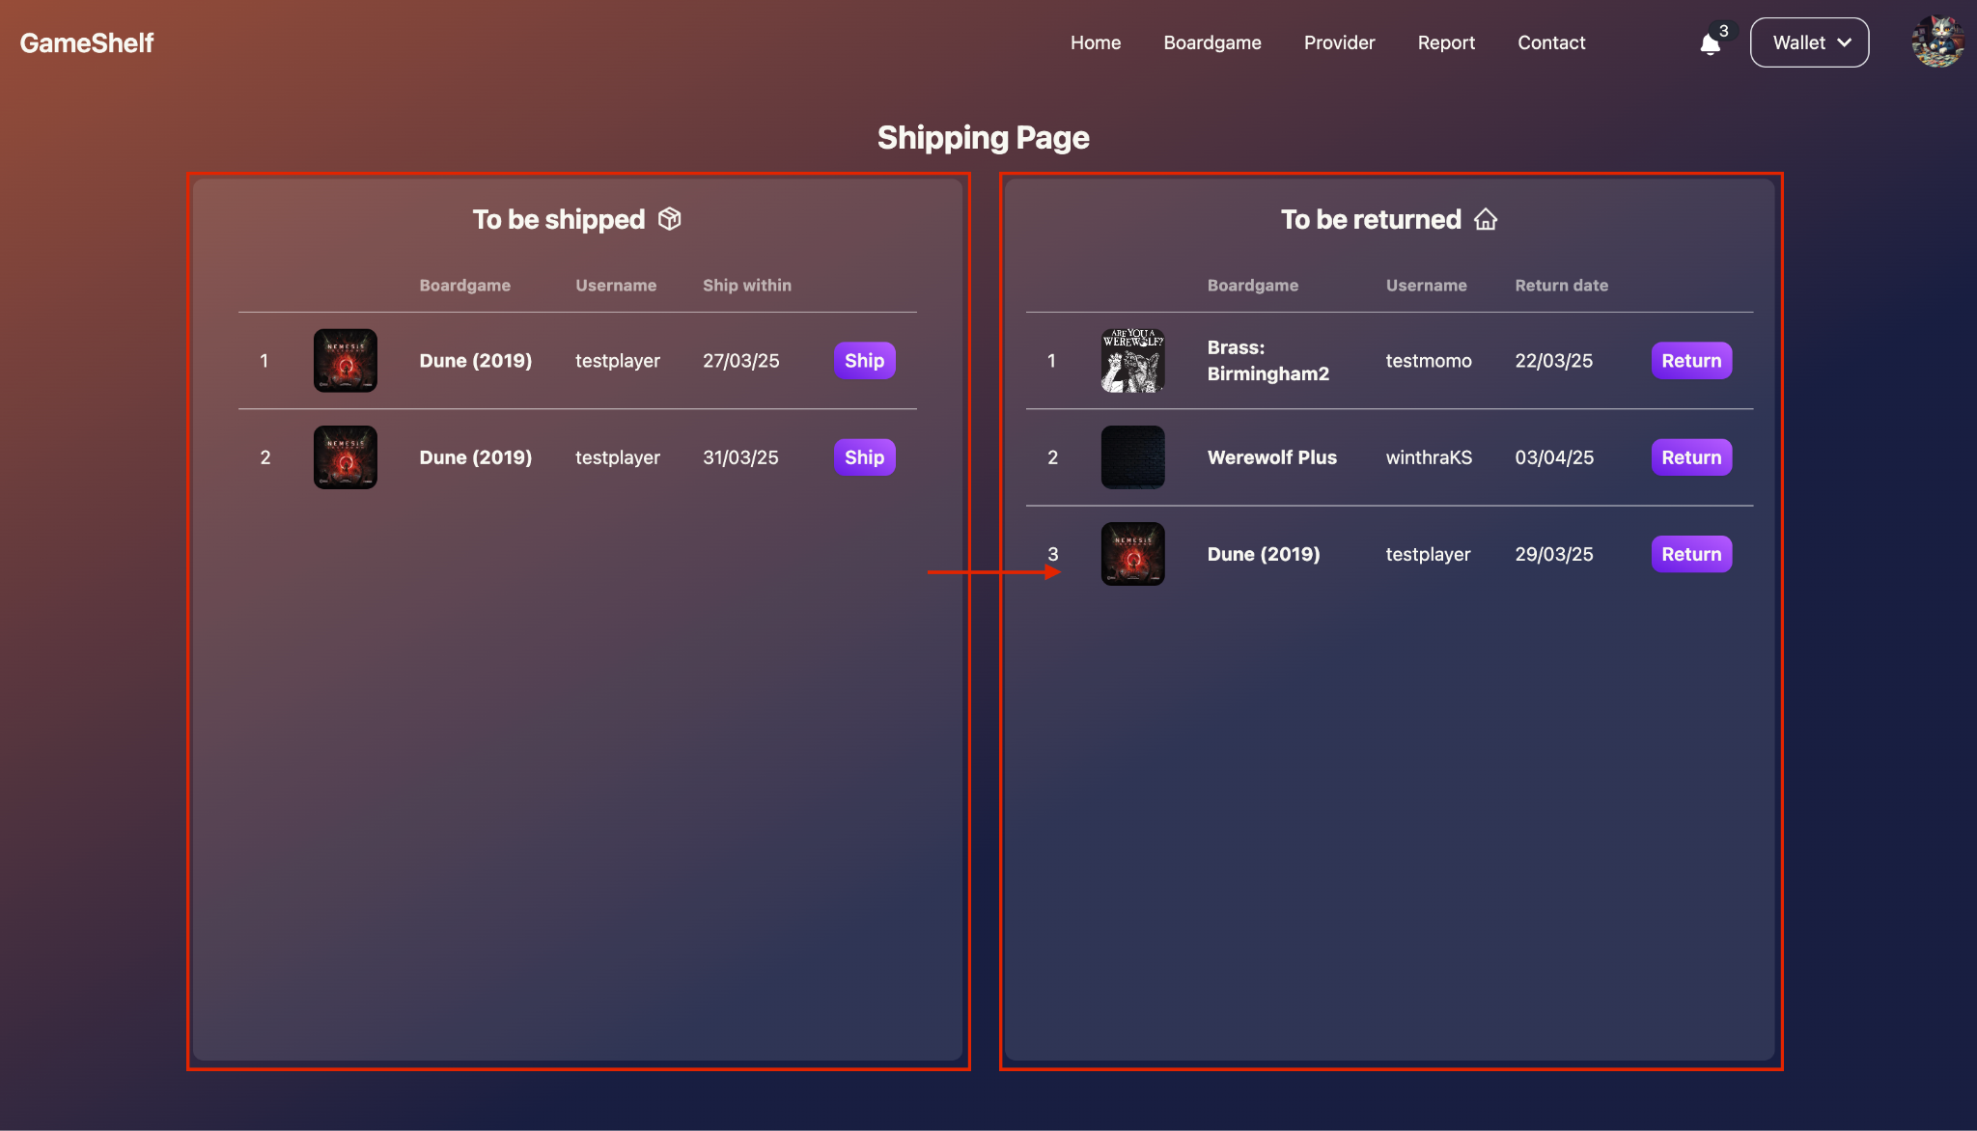

1. To manage the status after shipping, providers need to upload a picture of the boardgame to the website. (after shipped picture)

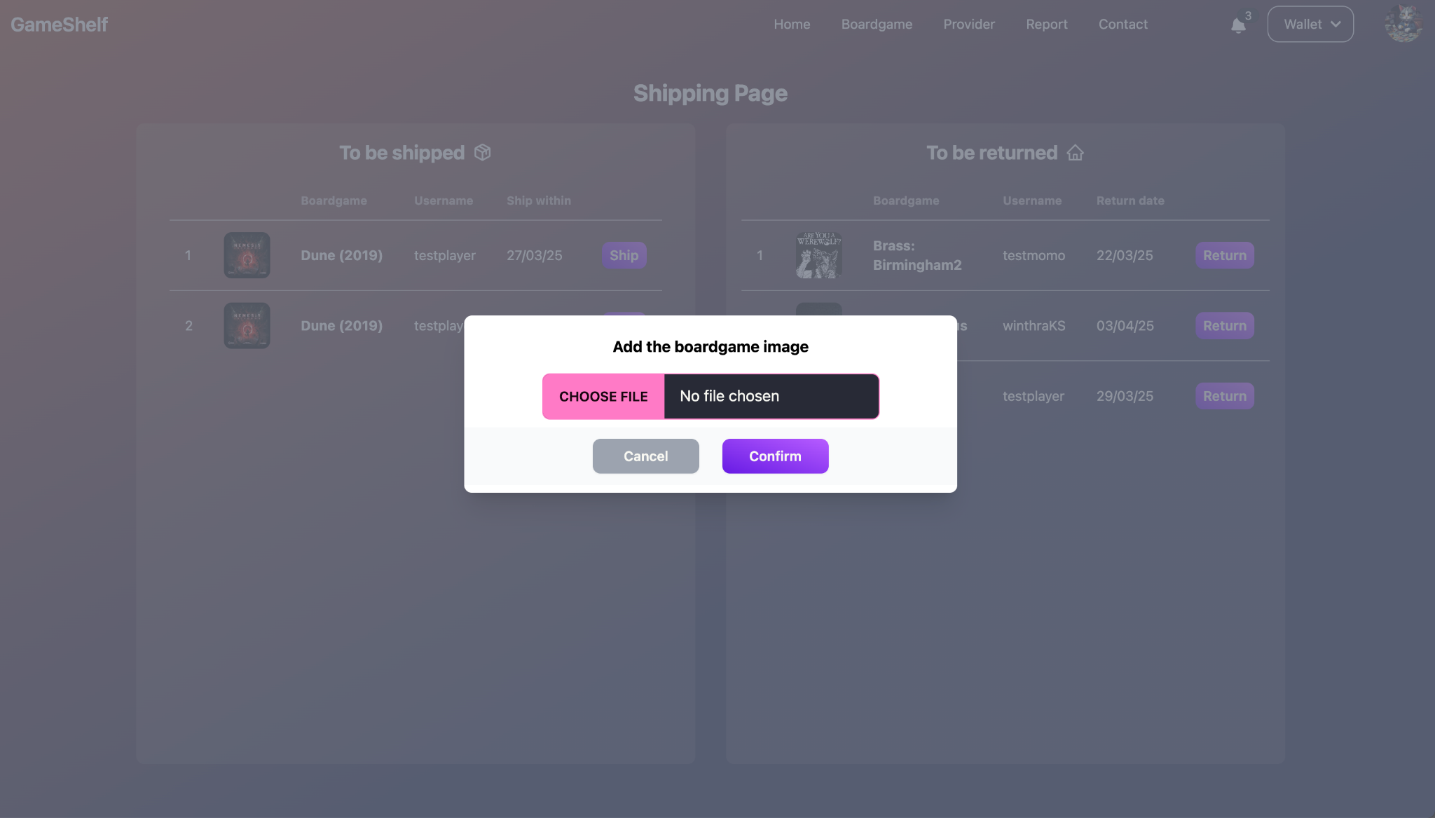

1. To manage the status after returning, providers need to upload a picture of the boardgame to the website (after returned picture)





## Function : Provider dashboard

Role : Provider

**Instruction**

1. Providers can manage and check the status of all board games in the dashboard page.
2. Providers can cancel the rental if the player pays too late after the rental was accepted by selecting the boardgame to cancel and clicking the cancel button to confirm.

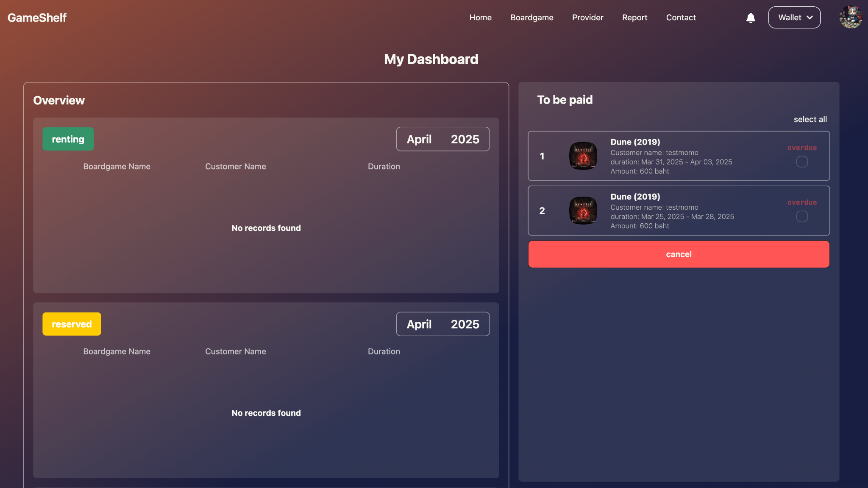

## Function : Check Review

Role : Provider

**Instruction**

1. Providers can see the reviews from their board games by going to their profile and then go to the bottom.

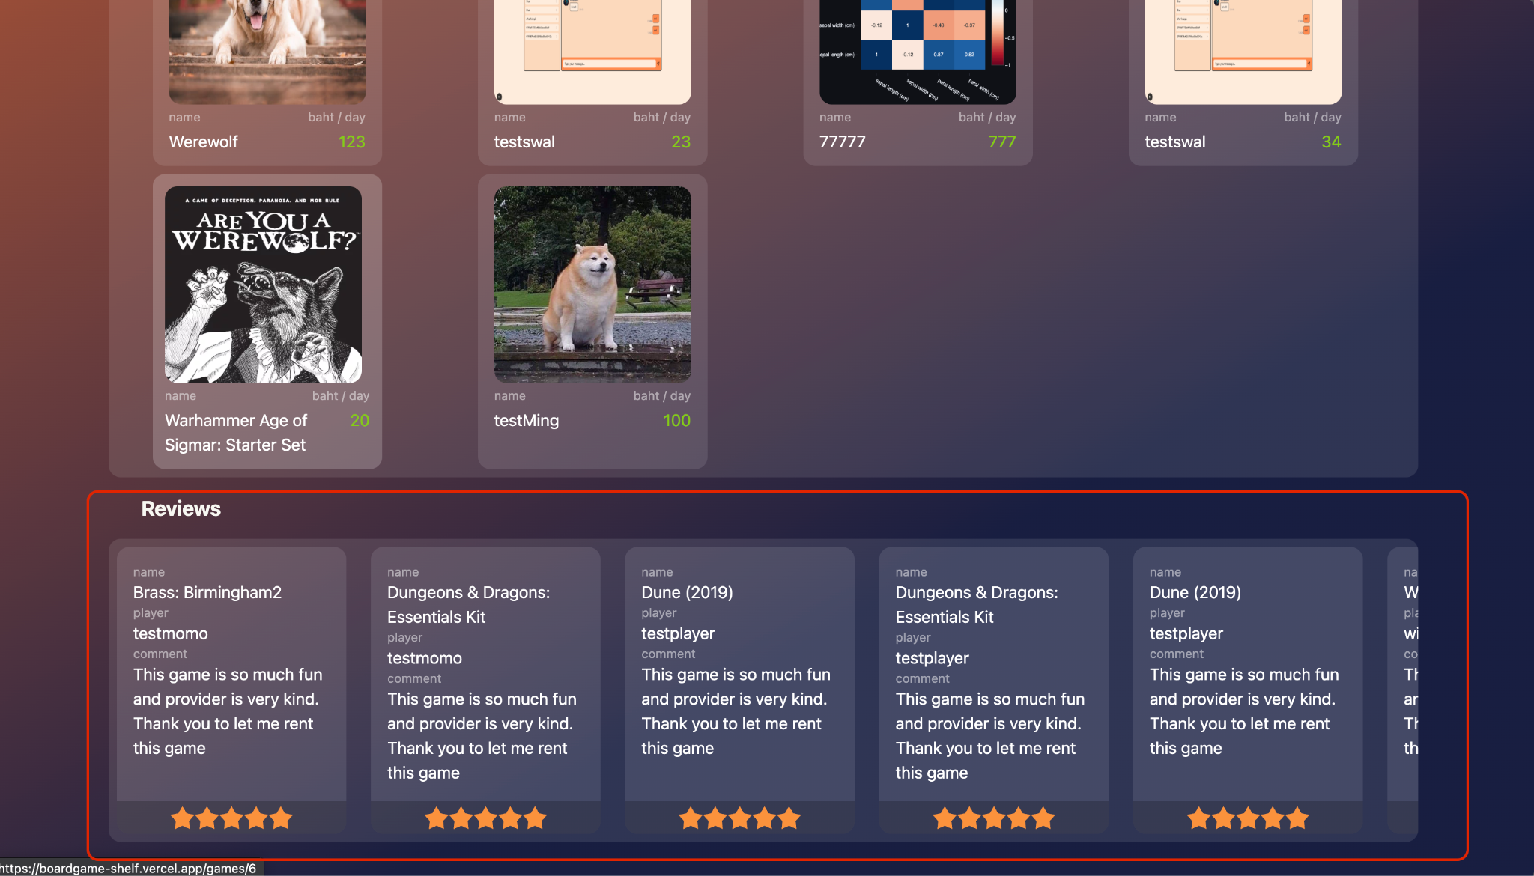

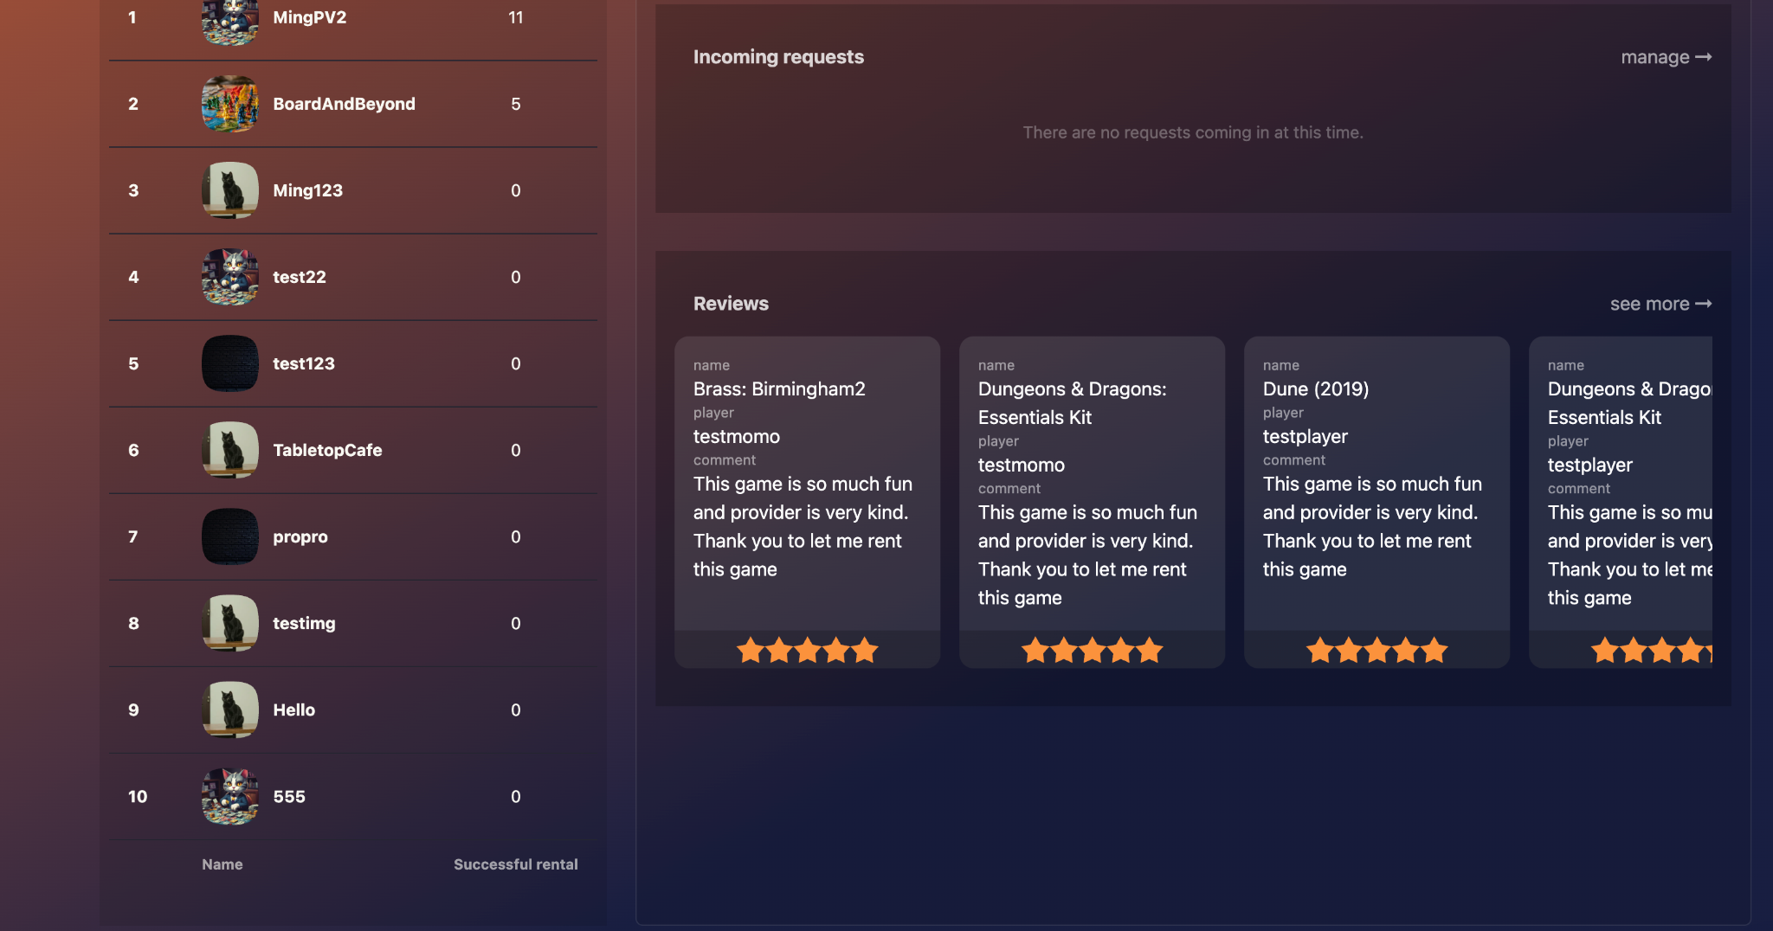

## Function : Income history

Role : Provider

**Instruction**

1. Providers can see the income history by going the income history page by clicking on the income history menu on their profile.

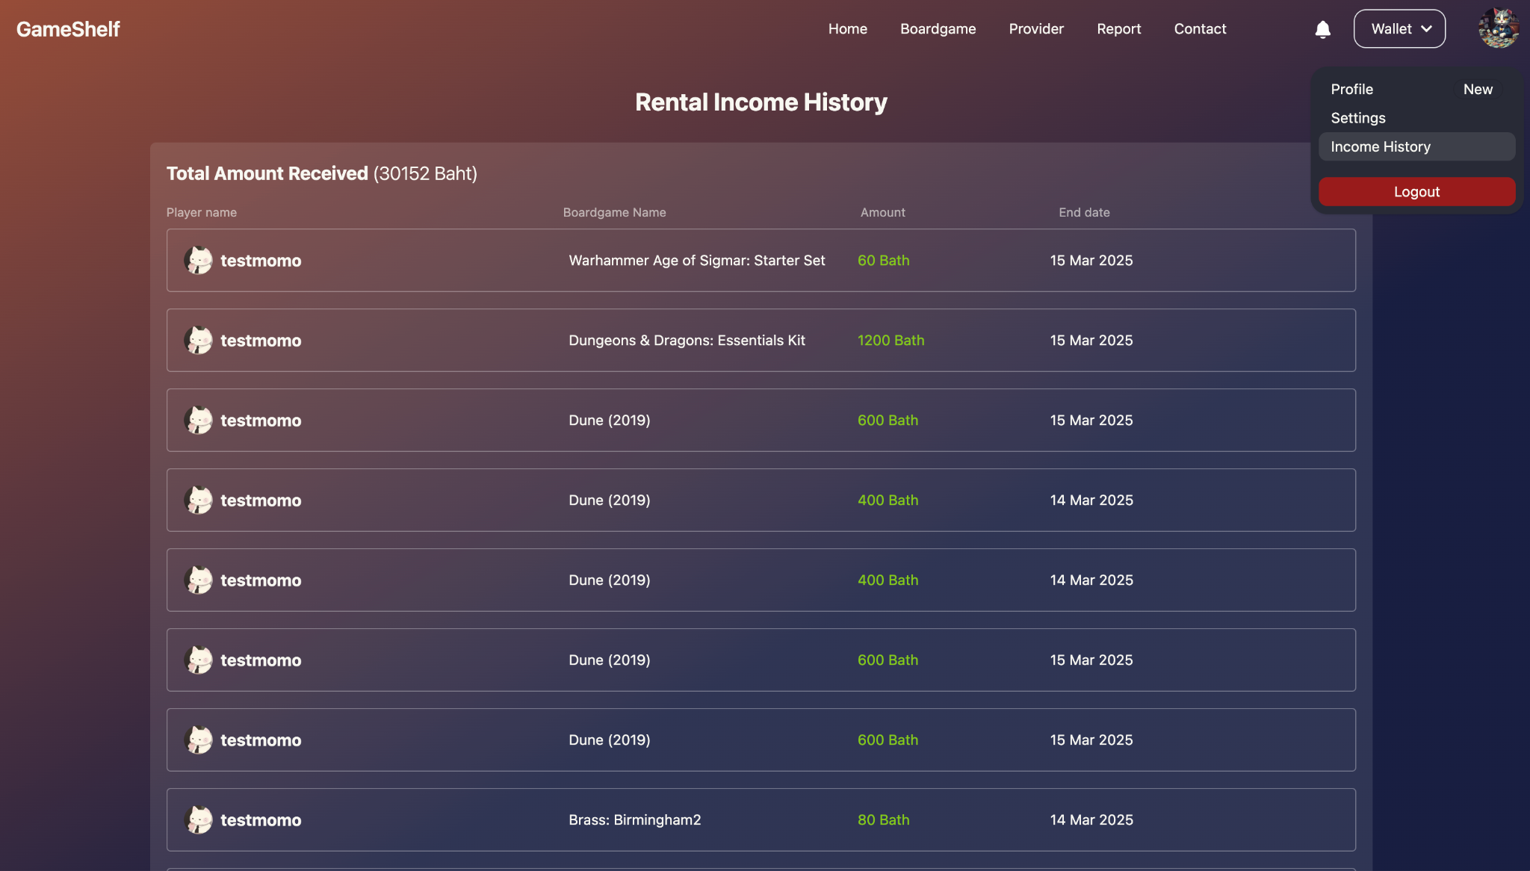



## Function : Manage provider

Role : Admin

**Instruction**

1. Admin can see the incoming verifications at admin-homepage

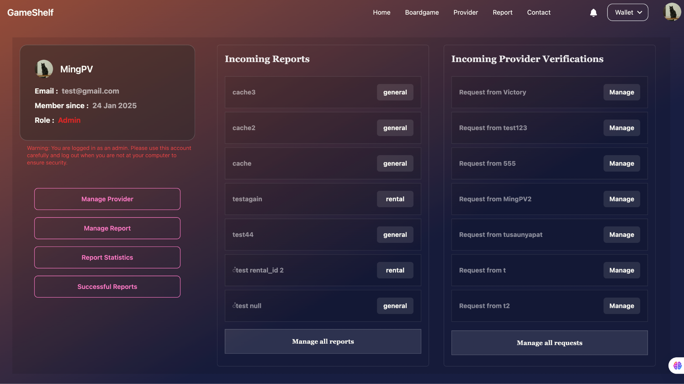

1. Manage the provider verification request by using the details that provider provided.

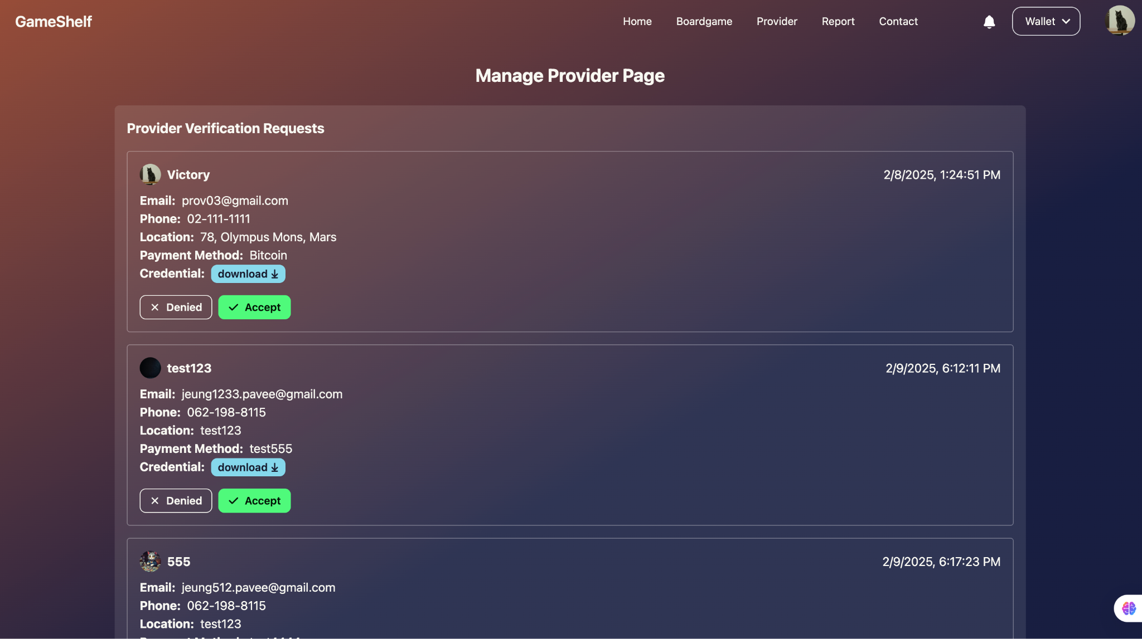

## Function : Manage report

Role : Admin

**Instruction**

1. Admin can see the incoming reports at admin-homepage



1. Report management page has 2 parts, the top is my responsibility and the bottom is the report that has no admin who is taking action at that time.

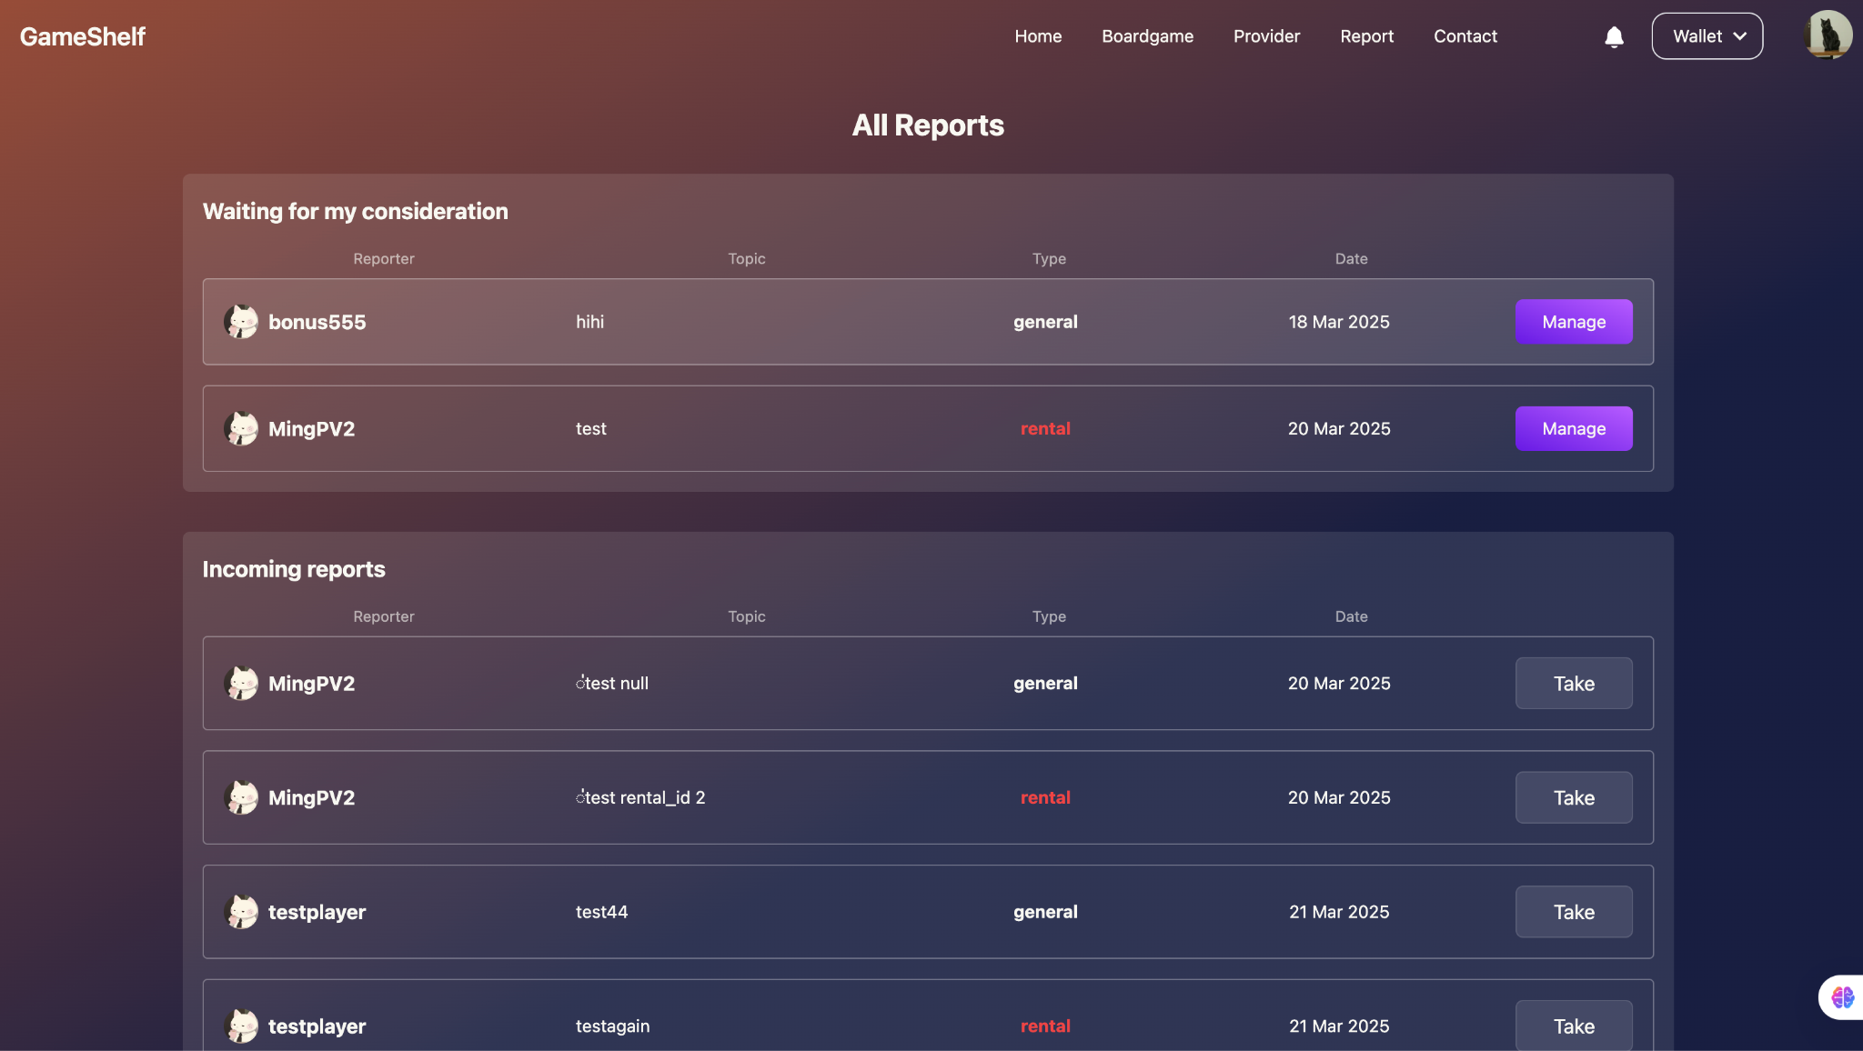

1. In general you can only ban the user but in rental type you can ban and give the player a refund for that rental.

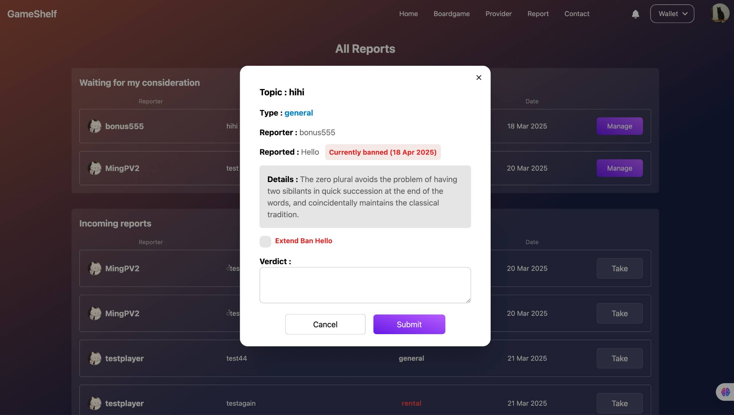

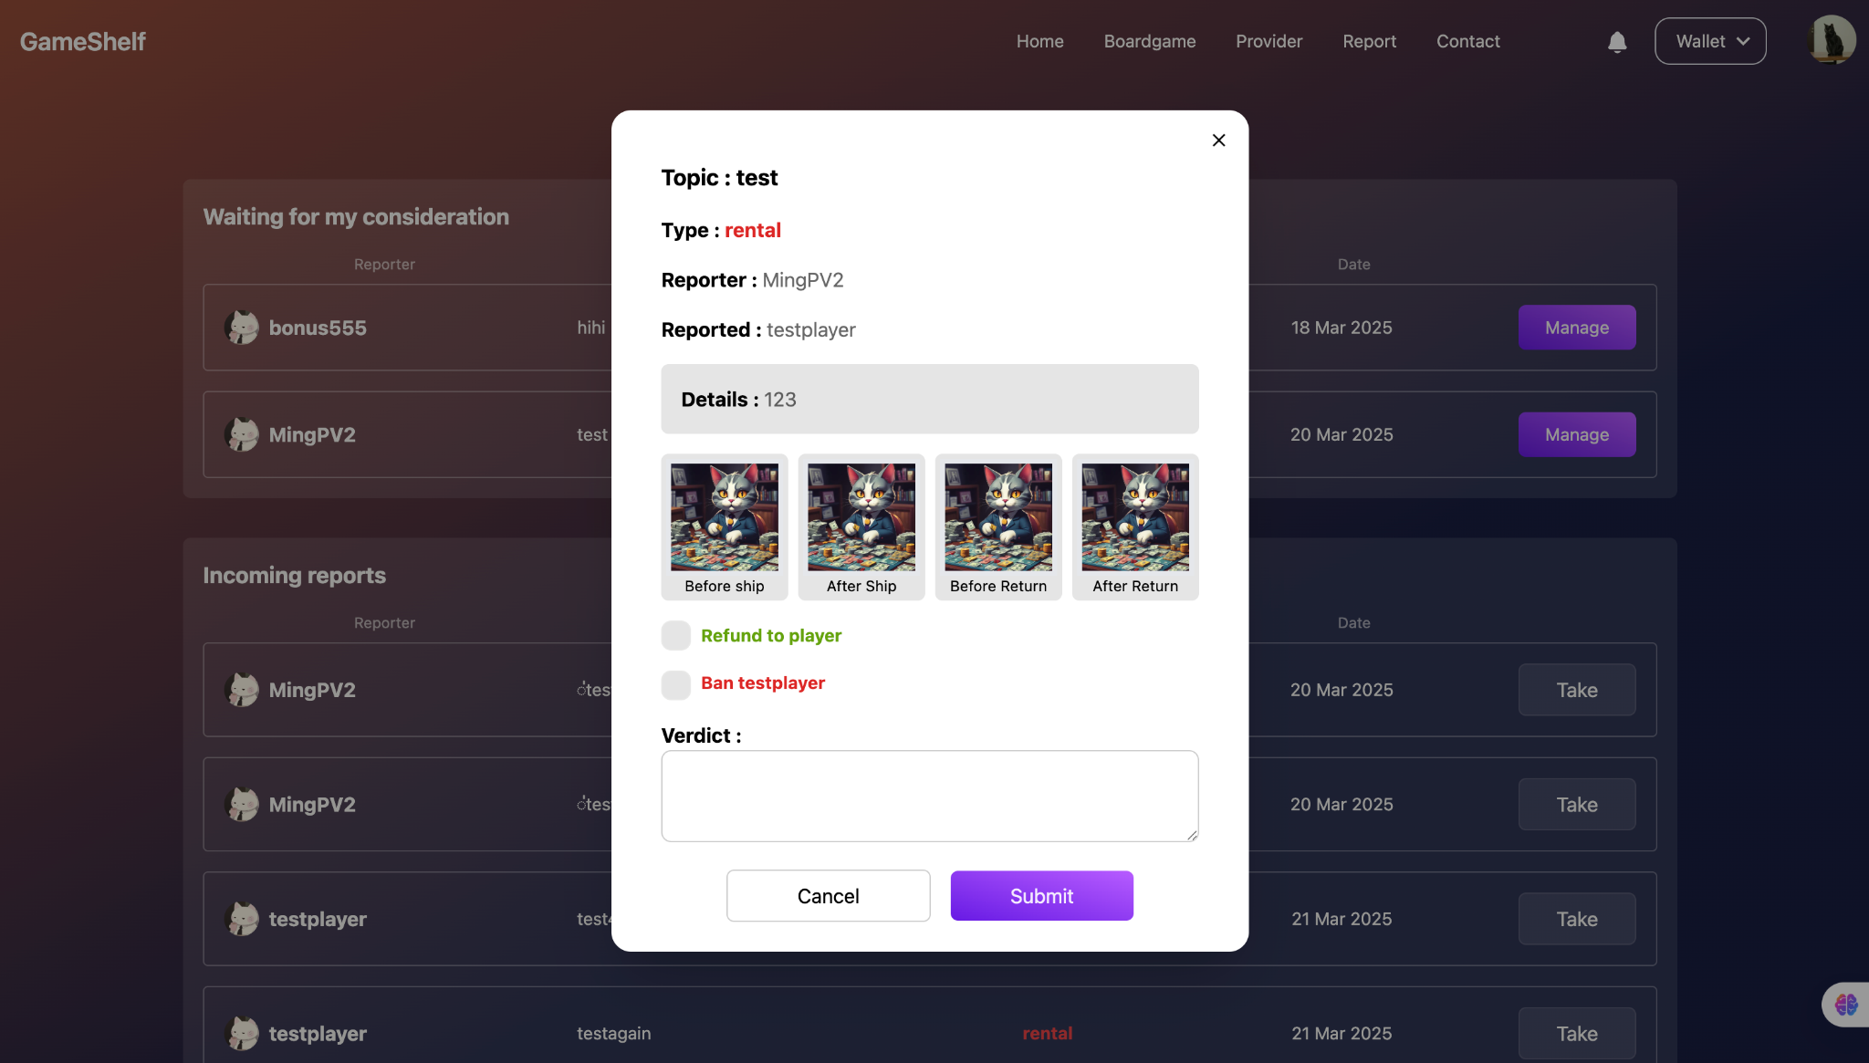

## Function : Report statistic / Unban

Role : Admin

**Instruction**

1. Admin can see the statistics of the report and users who got the report at the report statistics page.

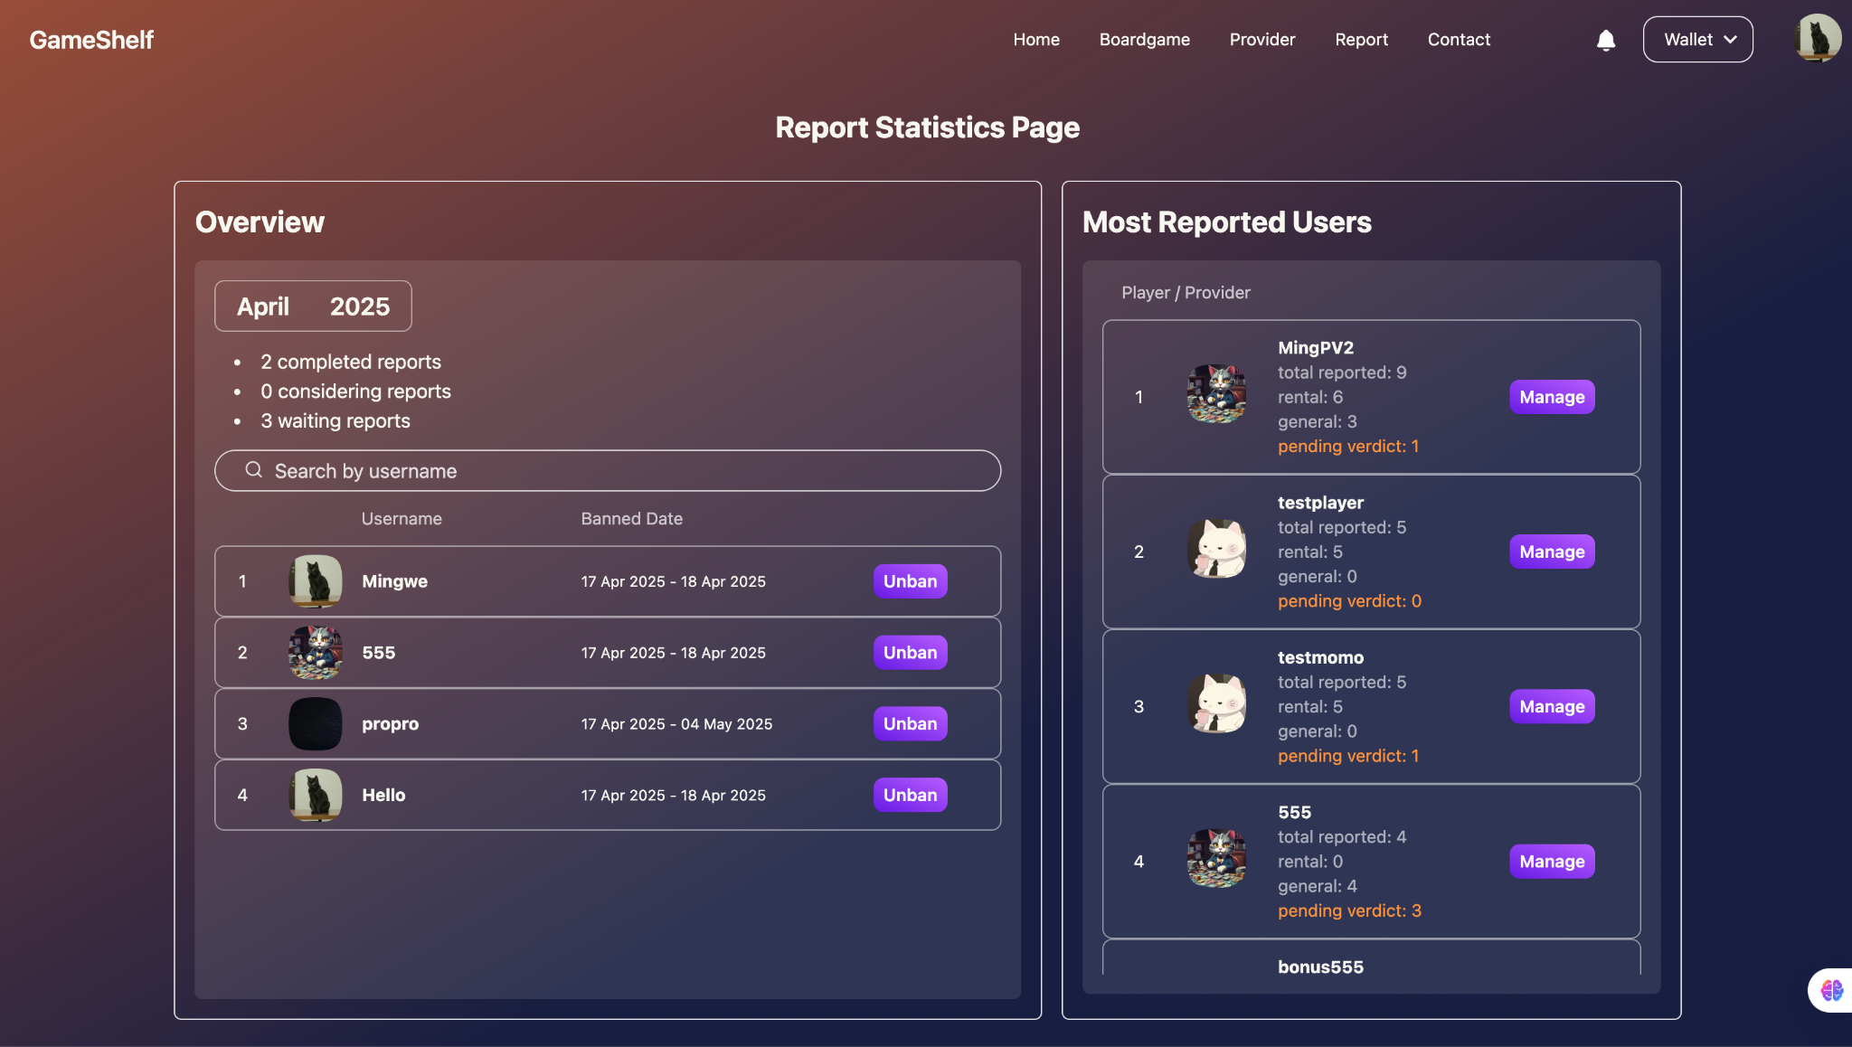

1. Admin can unban the users on the left side and filter the date.



## Function : Report history

Role : Admin

**Instruction**

1. Admin can see the report history by going to the report history page to manage the report in the past or getting the report data if needed.

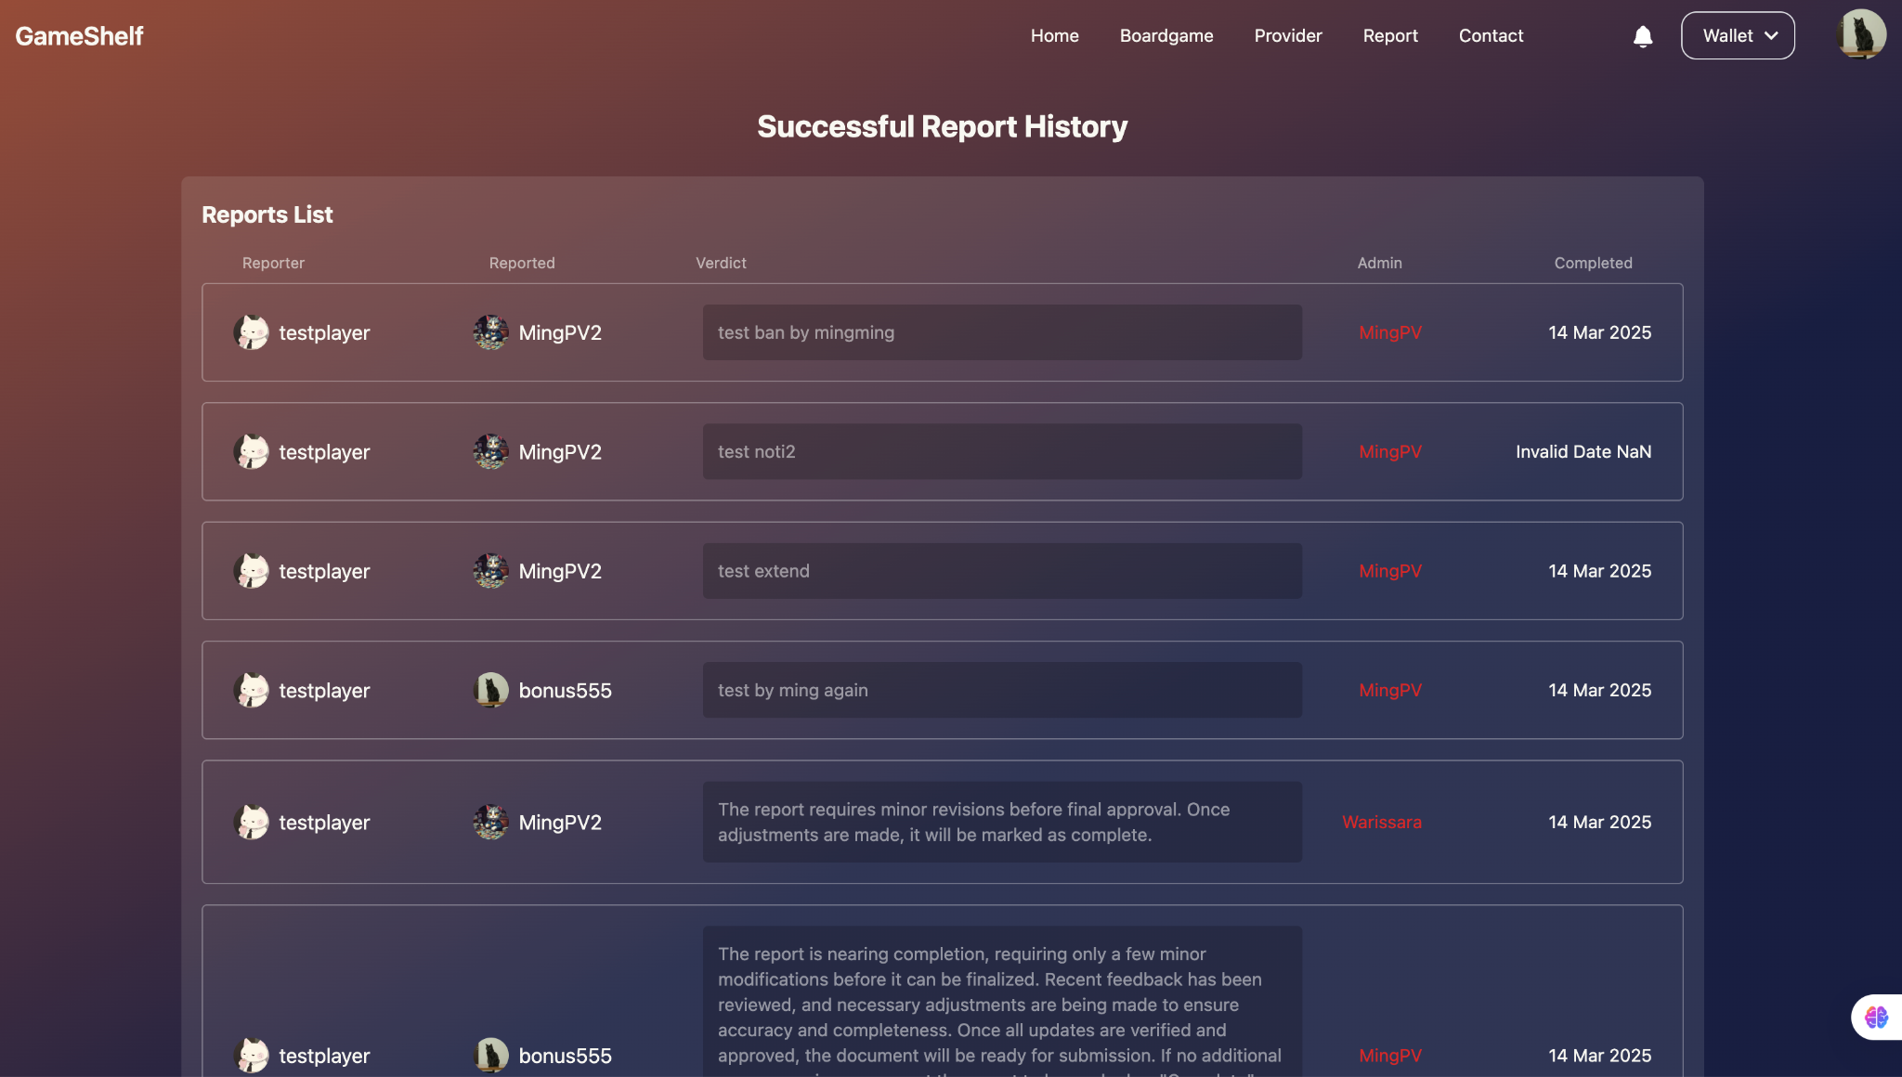

# Limitations of the implementation

Website performance

* Website performance is not good because we did not implement the cache for loading data

Admin UI

* Admin user interface is too similar to the player interface or provider interface and It is uncomfortable for the eyes if you have to work for long periods of time.

Payment system

* There is only one payment method to pay that is using a credit card. So that makes payment difficult.